**Introduction :-**

This Online Eye Care System can be used by Eye doctors or Optometrists to manage their practice. Out of all the Specialities in medical science this is one of the most frequently visited due to the requirement of repeated check – ups. This system can be used to save patient records, schedule appointments and place orders for custom eye equipment.

Each patient registered at the hospital will be assigned a unique file which will consist of data from all their visits to the hospital. The doctor who conducts the assessment will save all eye power related information and prescriptions on the system. This will make the whole process transparent for the user, as they will be able to view the history of their eye problems in one location.

This Online Eye Care System can be accessed by an optician of the user’s choice and they will be able to book new eye glasses or contact lens at any time using the latest prescription. If the patient wishes to transfer to a new doctor or seek a second opinion the system will allow easy sharing of the data in the file via the internet. The third party will be able to view the file till the user decides to revoke access.

The user can also schedule appointments with their optometrist using this system and will receive information about confirmed bookings.

**Existing System :-**

* The existing Online Eye Care System is fragmented because the whole process of getting prescriptions and booking eye glasses is completed by different vendors.
* It is important for the user to visit each place and provide the files required. This wastes the customer’s time and also increases the chances of error for these different vendors. They will have to check whether they have the correct file on multiple occasions.
* Reports are prepared manually as and well needed .Maintaining of reports is very tedious task.

**Need and Scope of System :-**

**Objectives :-**

The proposed Online Eye Care System aims to make the process easier by making it easy for users to share files. This file will be the original uploaded by the optometrist and will be routinely updated. The patient just needs to ensure that the optician has access to the files. Eye equipment such as sun glasses, eye glasses , computer glasses and contact lenses can be ordered remotely via the internet as well when these tamper free files are used from this system.

It will help in maintaining the patient records without any difficulty.

The user interface must be simple and easy to understand even by the common man .This will be one of the applications that will help in maintaining the details of the services that are given to the patient just with the one click.

* **Advantages of Proposed System :**
* This system will reduce the manual operation required to maintain all the records of booking information.
* All report stored in database and easily maintained the patient record data and recovery the patient report details.
* Patient , doctor and optical stock details are generated by admin.
* Huge amount of patient reports stored and retrieved from the database.
* This software can be used to buy eye accessories likes sunglasses ,eyeglasses ,computer glasses ,contact lenses. Customer services can be satisfied easily.

**Requirement Engineering :-**

**Requirement Gathering:-**

Requirements gathering is the process of collecting and documenting the requirements or specifications that a software system must meet. It is an important step in the software development process because it helps to ensure that the final product meets the needs of the stakeholders and end users, and that it is developed within the constraints of the project, such as budget and schedule.

During the requirements gathering process, stakeholders such as customers, business users, and subject matter experts are interviewed and consulted to determine what the software system must do, and what requirements it must meet. This information is then used to create a set of detailed requirements that serve as the foundation for the design and development of the system.

If requirements are not gathered properly it may lead to incorrect or incomplete understanding of the problem. This could result in solutions that do not meet the needs of the stakeholders, which can result in rework, cost overruns and delays in the project.

**SRS:-**

The production of the requirements stage of the software development process is Software Requirements Specifications (SRS) (also called a requirements document). This report lays a foundation for software engineering activities and is constructing when entire requirements are elicited and analyzed.

SRS is a formal report, which acts as a representation of software that enables the customers to review whether it (SRS) is according to their requirements. Also, it comprises user requirements for a system as well as detailed specifications of the system requirements.

The SRS is a specification for a specific software product, program, or set of applications that perform particular functions in a specific environment. It serves several goals depending on who is writing it. First, the SRS could be written by the client of a system. Second, the SRS could be written by a developer of the system. The two methods create entirely various situations and establish different purposes for the document altogether.

The first case, SRS, is used to define the needs and expectation of the users. The second case, SRS, is written for various purposes and serves as a contract document between customer and developer.

**Front End :-**

**Introduction to ASP.Net :**

ASP.NET is a server-side technology which provides services to create, deploy, and execute web applications, and web services. A web service is an application that can be invoked programmatically and expose some service on the web. They use standard Internet Communication protocol like XML and SOAP.

Web services support a distributed computing platform for the web. Web applications are created using Web Forms in ASP.NET. ASP.NET provides object-oriented execution model. The execution of application is under CLR. ASP.NET application also need to be hosted on IIS (Internet Information Services). But for development purpose ASP.NET has an in built ASP.NET Development Server for testing and running a web page during a development stage. ASP.NET development server is included with Visual Web Developer, is a web server that runs locally on Windows Operating System.

It is specifically built to serve or run ASP.NET web under the local host scenario. In other words, the ASP.NET Development Server will serve pages to browser requests on local computer. It will not serve pages to another computer. ASP.NET follows a code behind model. User Interface is separated from code. Code for the page and the events can be written in C# or VB.NET or J#.

**Features of ASP.Net :**

• We can create applications such as windows applications, web applications, console applications and mobile applications which has user interface.

• The former lets you create mobile based web application were as the later lets you right application for pocket PC or others windows CE based devices which run on a stripped-down version of framework (compact framework).

• .NET provides code-based security. .NET lets you decide the way you want your application to be used.

• Simple programming object-oriented model built on .NET – Less code needs to be written, hence easier to create and maintain. There is separation of code and User Interface.

• Multi browser support – ASP.NET supports multiple browsers.

• Web forms and Web services – Web application can be created very easily using Web Forms. Rich set of controls are available to make the application interactive. New controls like validation controls, login controls, and many more available to make the developers easy.

• Session management and caching – Session management allows web server to identify each users request uniquely, thus knows the current state of the user. If multiple users request the same web page at the same time, then performance can be improved by storing that page in the dedicated memory known as cache.

• Security – ASP.NET provides features like authentication and authorization to make the web Application secure.

• XML configuration – Configuration settings related to web and machine are stored in XML format.

**History of ASP.Net :**

History starts from the invention of BASIC (Beginners All purposes Symbolic Instruction Code) in 1964, a language that is easily learnt & used by beginner programmer. In 1975 Microsoft was a new company. A version of BASIC (MS BASIC) was the first product. It made that become successful. MS BASIC & its successor QBASIC (Quick Basic) became most widely available versions. After these versions MS came with a new product that combined the basic language with a development environment that enables the programmer to graphically design user interface.

This is VB 1.0 until its version 5.0 which released in 1997. It was interpreted language which resulted relatively poor performance as compared to VB C++, Delphi and other compiler language. Another key feature of VB is object oriented i.e.; it revolves around readymade objects. The next version of VB is VB.NET. Actually, version number of VB.NET is VB.7.0 & it is pure object-oriented language.

**Introduction to C# Language:**

• C# language is intended to be simple, modern, general purpose, object oriented programming language.

• The language and implementations thereof should provide support for software engineering principles such as strong type checking, array bound checking, detection of attempts to use uninitialized variables, and automatic garbage collection. Software robustness, durability and programmer productivity are important.

• The language is intended for use in developing software components suitable for deployment in distributed environments.

• Source code portability is very important, as is programmers already familiar with C and C++.

• Support for internationalization is very important.

• C# is intended to be suitable for writing applications for both hosted and embedded systems, ranging from the very large that use sophisticated operating system, down to the very small having dedicated functions.

• Although C# applications are intended to be economical with regard to memory and processing power requirements, the language was not intended to compete directly on performance and size with C or assembly language.

**Back End :**

**Introduction to SQL SERVER:**

SQL server is used as Backend to manage the database. SQL is used to create, maintain and fire query on relational database by using the regular English words for its commands, which makes it easy to use.

▪ SQL is declarative i.e., you specify what kind of data you want, and then RDBMS is responsible for figuring out the data.

▪ SQL is based on set theory, relational operators such as AND, OR, NOT are used to perform operations on the data.

▪ SQL includes all arithmetic operations, predicates for comparison, string matching, summary operations, group by and having clause etc.

▪ SQL provides a view of the specification of database operation that would produce a desired table.

▪ SQL is generally used in multi-user system, where user will log in by using Authentication ID’s. Actions in SQL environments are created to a specific authorization ID, which usually corresponds to a user.

SQL is available in two forms:

1) Interactive SQL: It is used to operate directly on a database to produce output. Here once you enter the command, you can see the output immediately.

2) Embedded SQL: It consists of SQL command put inside programs that are written in other languages. The output of SQL command is embedded in SQL and is passed off to the variables or parameters used by programs in which it is embedded.

**SQL Command are categorized as:**

1. Data Definition Language (DDL):

It consists of those commands that create objects such as table in database. The database schema is specified by the set of definitions expressed by special language called data definition language. The compilation of DDL statements is a set of tables.

1. Data Manipulation Language (DML):

DML is:

1. Retrieval of information stored in database.

2. Insertion of new information into the database.

3. Deletion of information from the database.

4. Modification of information stored in database.

1. Data Control Language (DCL): It consists of features that determine whether a user is

permitted to perform a particular action.

**Sitemap:**

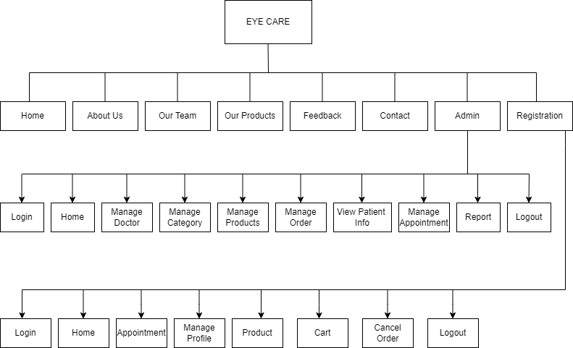

Represent the information that should be kept in mind when making a decision and this diagram use we are calculate how many entities are included in the system.

Following are the different standard signs used in these diagrams and they are representing with its meaning.

* **Process:-**
* **Entity:-**
* **Database:-**
* **Flow of Data:**

**Context Level DFD:-**

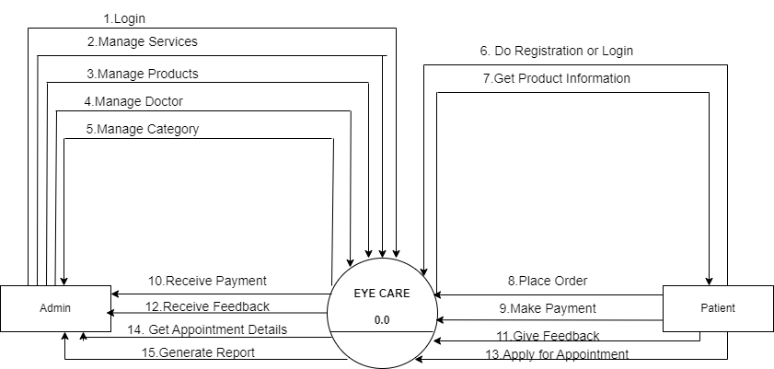

**First Level DFD for Admin:-**

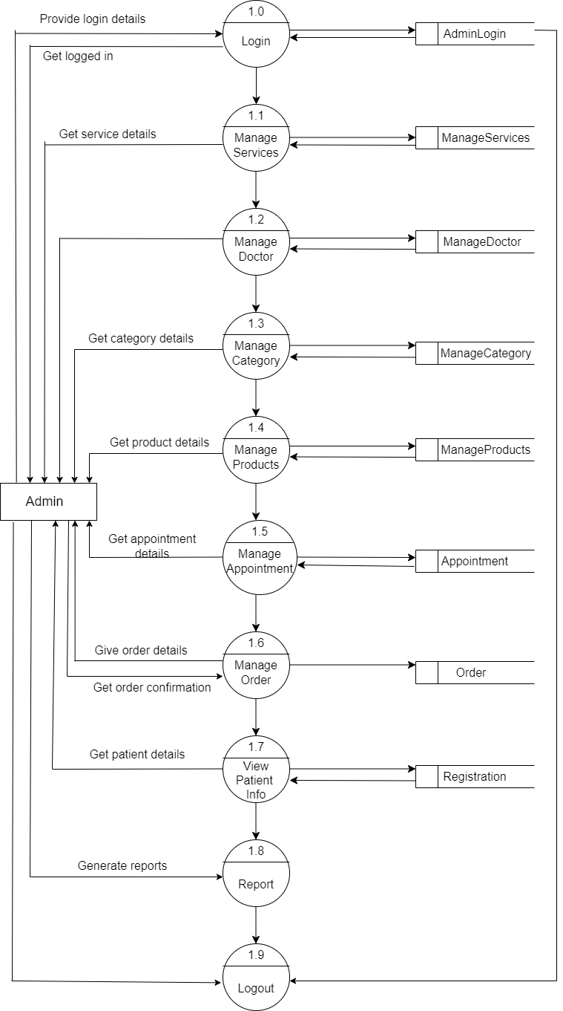

**First Level DFD for Patient:-**

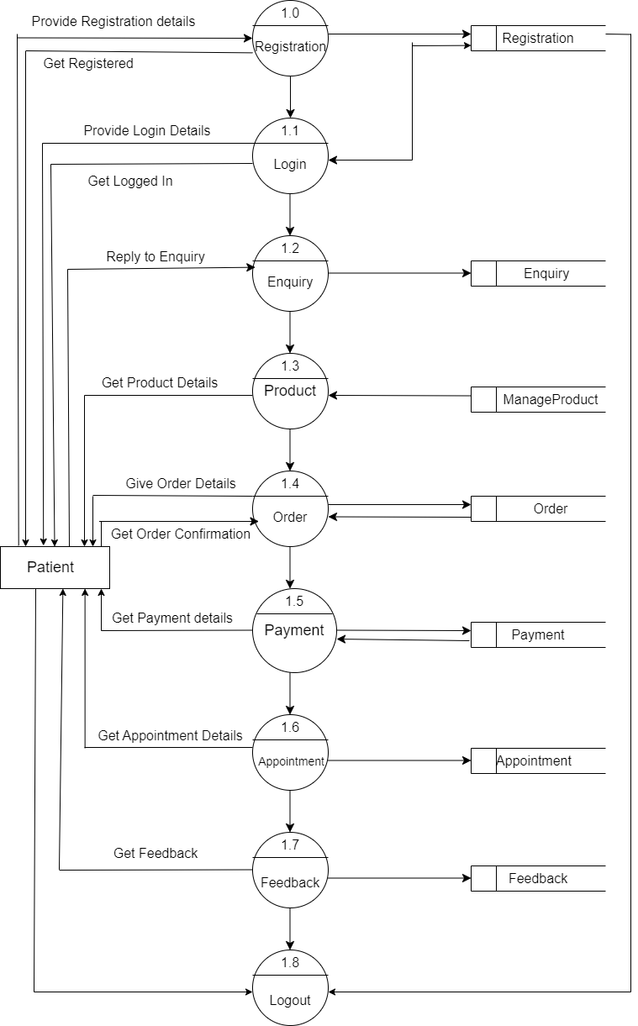

**ERD :-**

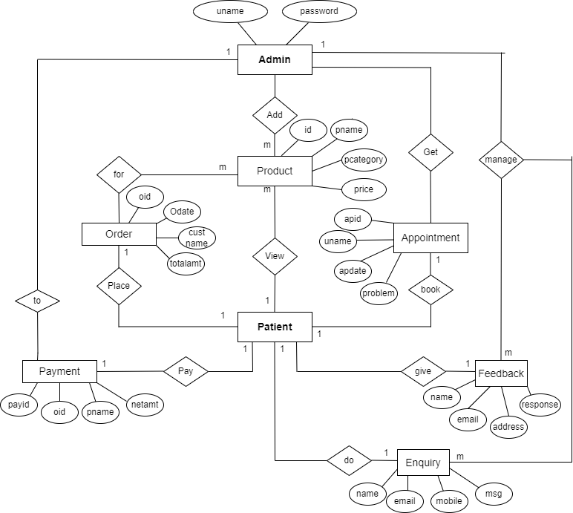

**Use Case Diagram:-**

Admin

User

**Solution Explorer:-**

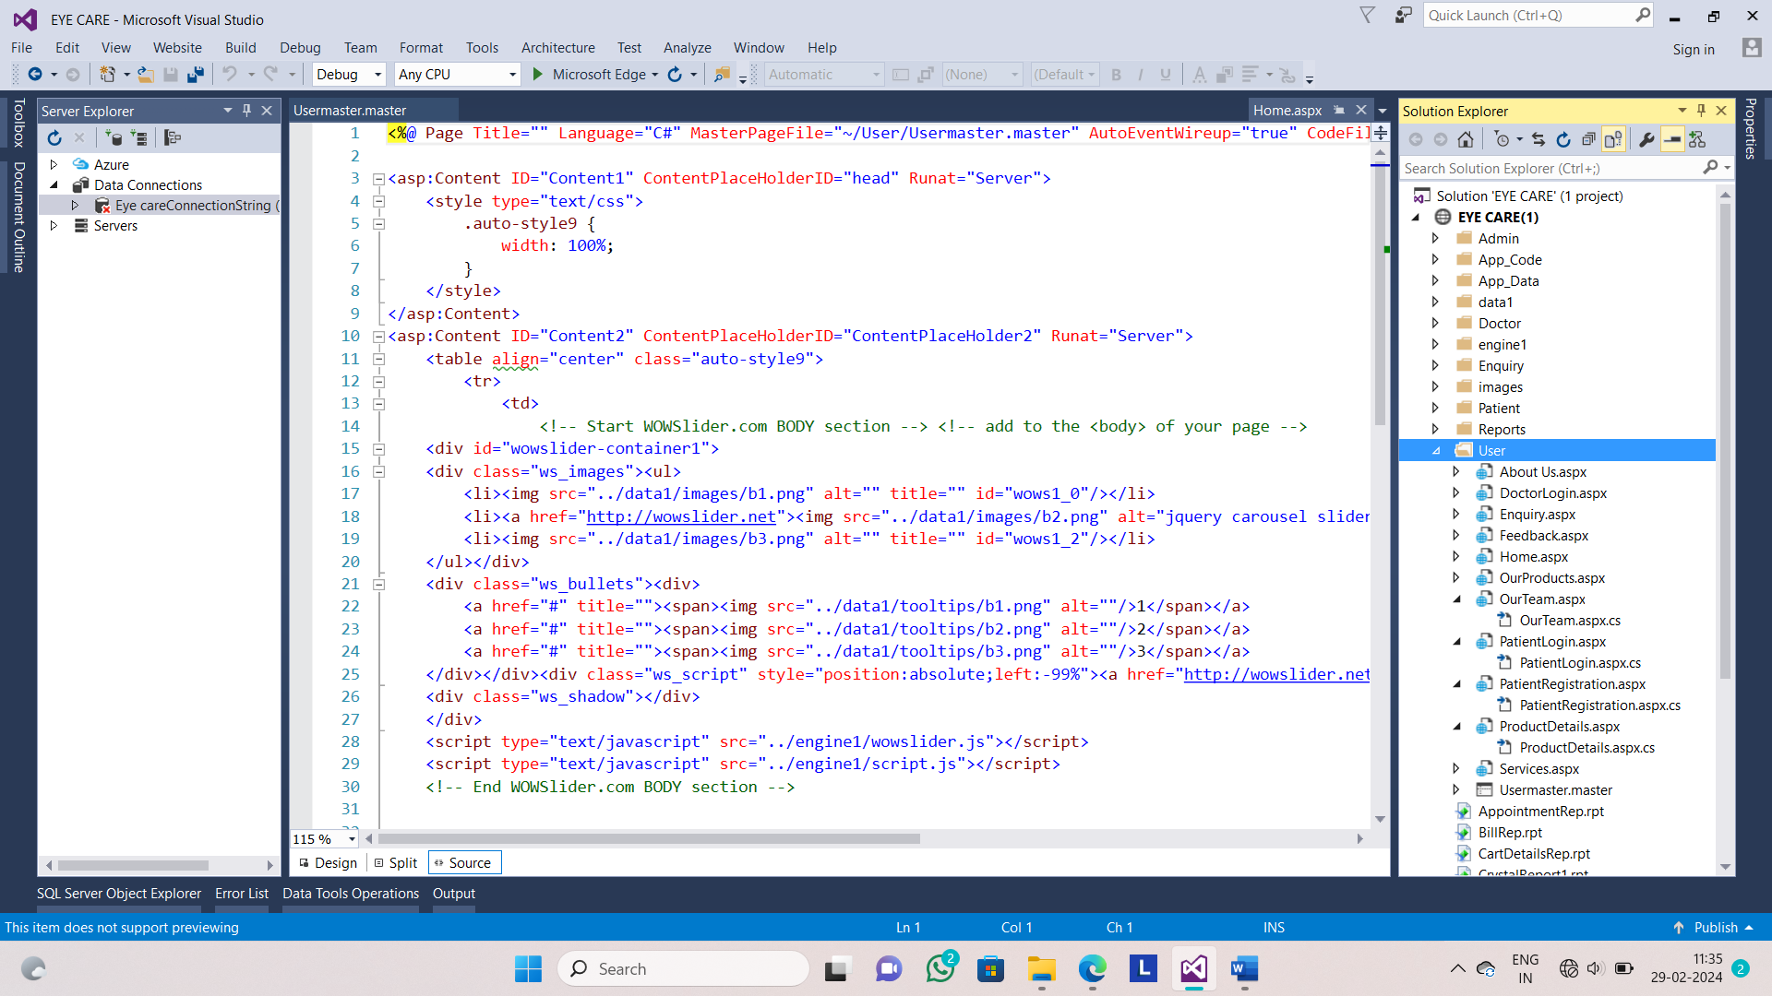

**Database:-**

**Table Name:-Registration**

**Design View:-**

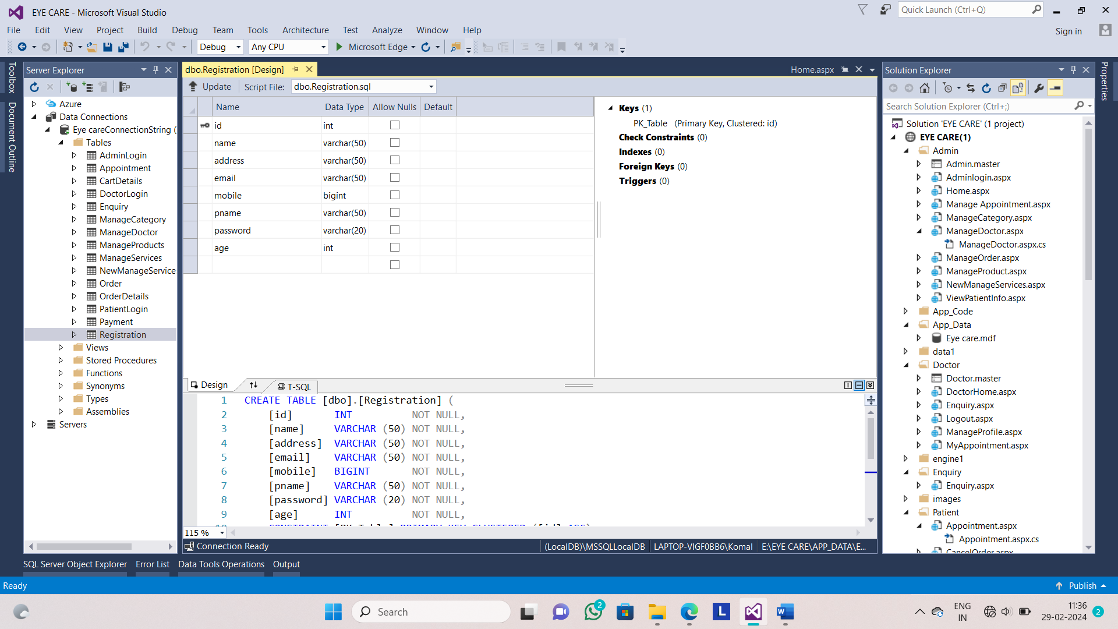

**Table Name:-Order detail**

**Design View:-**

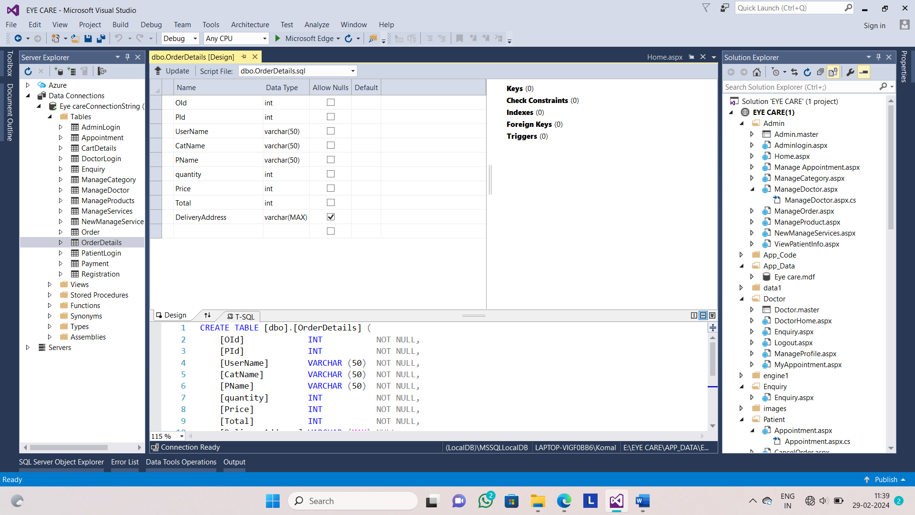

**Table Name:- Order**

**Design View:-**

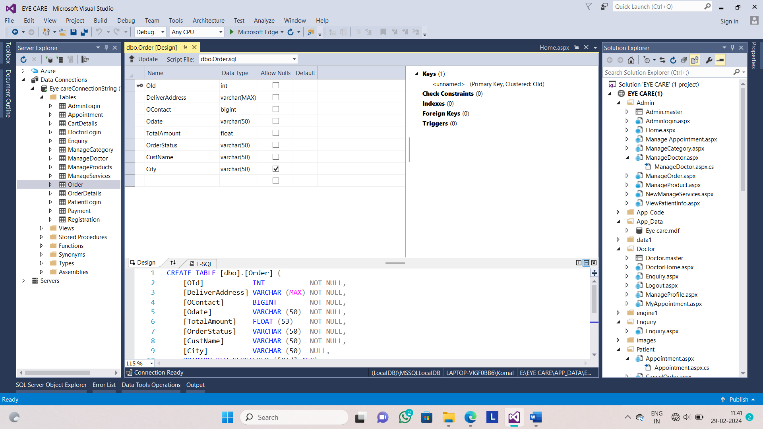

**Table Name:-Manage Services**

**Design View:-**

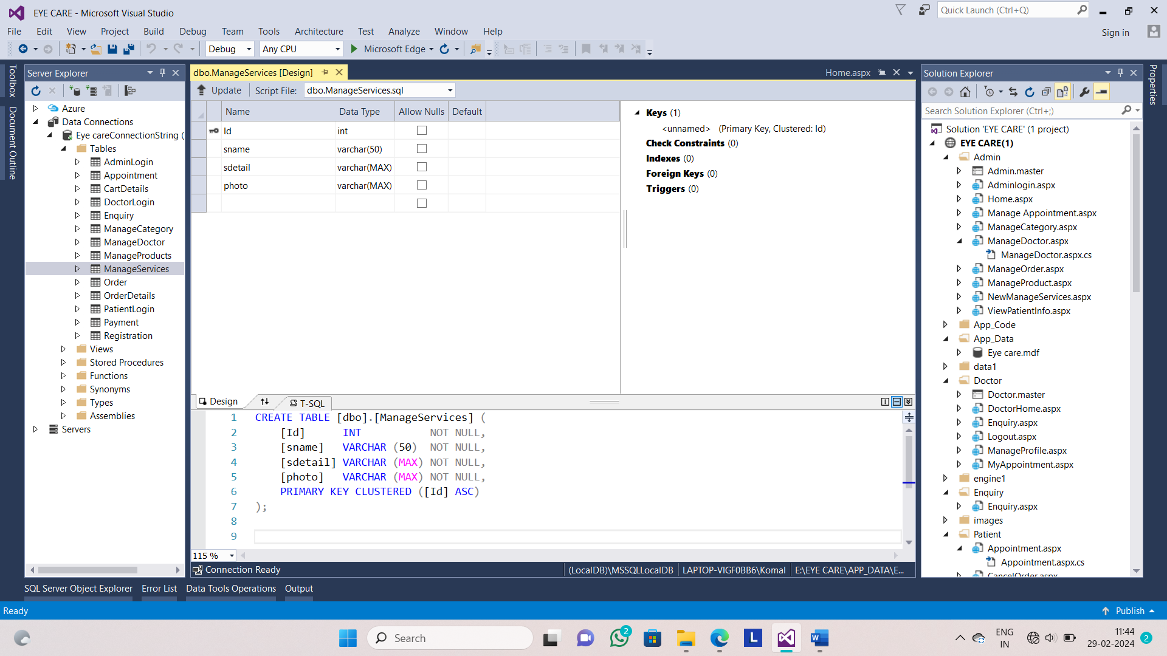

**Table Name:-Manage Products**

**Design View:-**

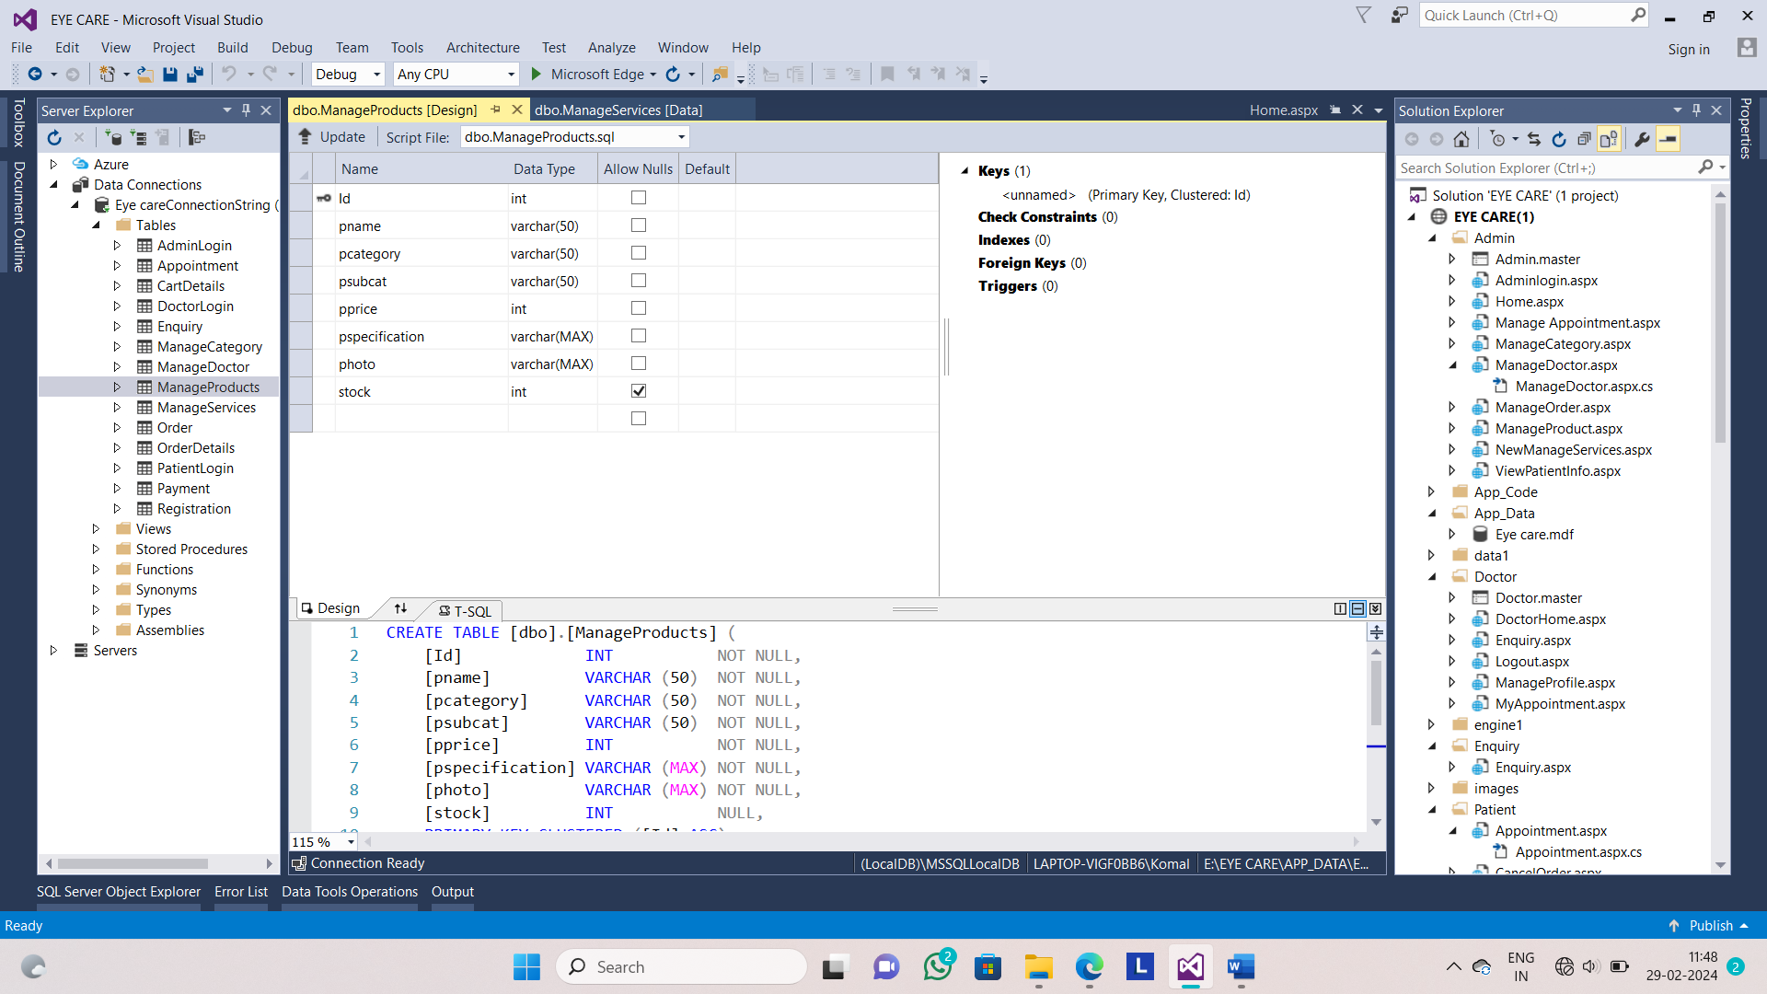

**Table Name:-Manage Doctor**

**Design View:-**

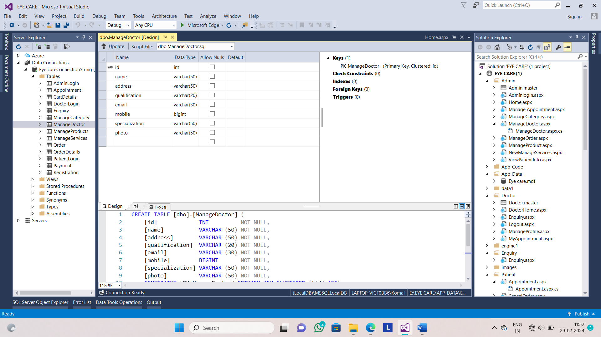

**Table Name:-Manage Category**

**Design View:-**

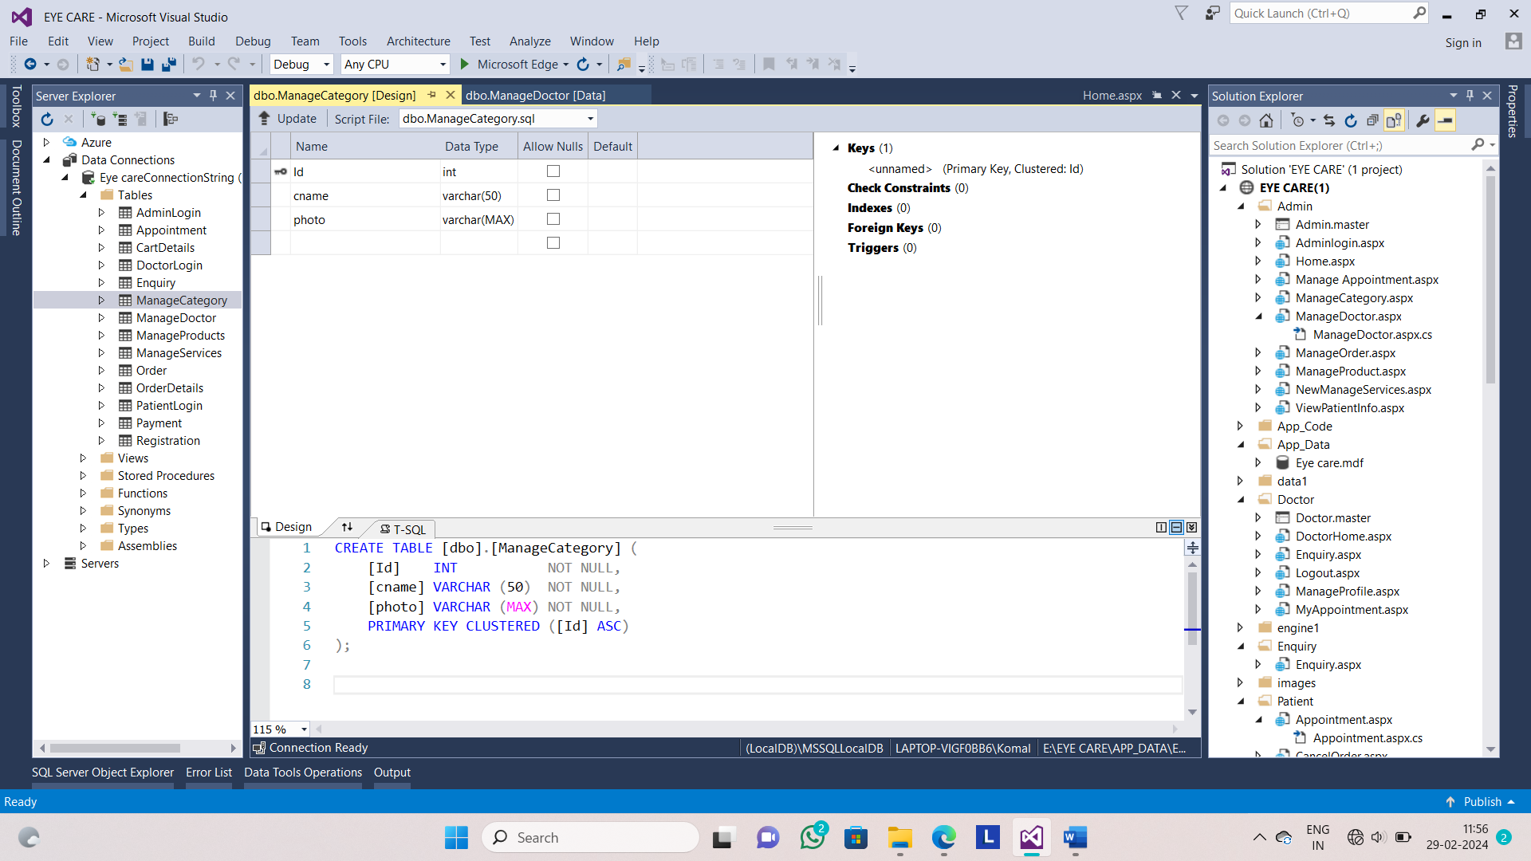

**Table Name:- Appointment**

**Design View:-**

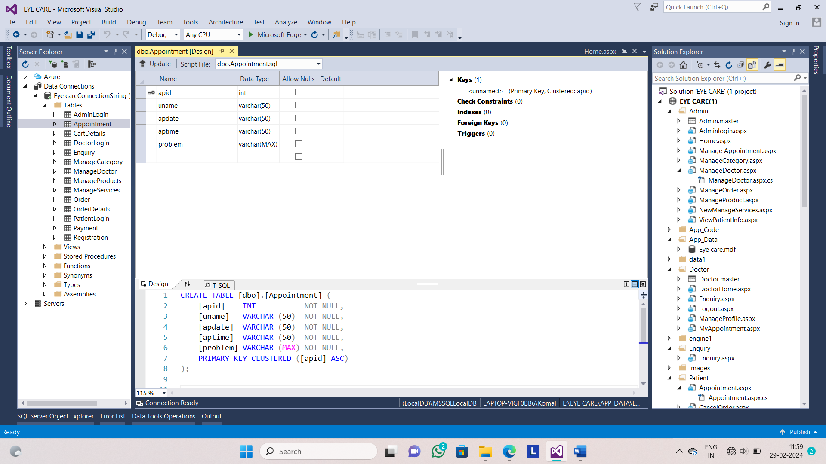

**Table Name:- Feedback**

**Design View:-**

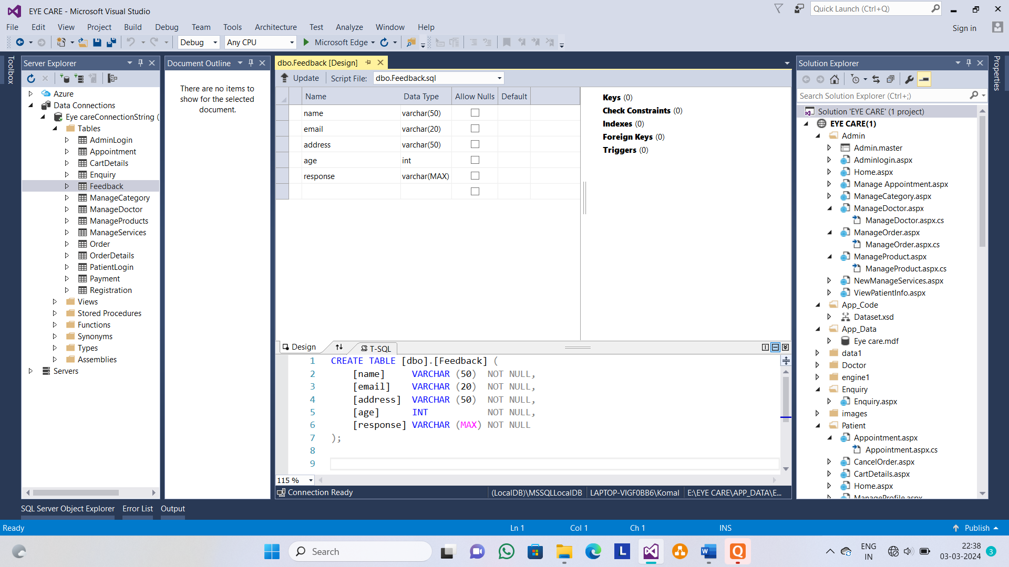

**Table Name:- Enquiry**

**Design View:-**

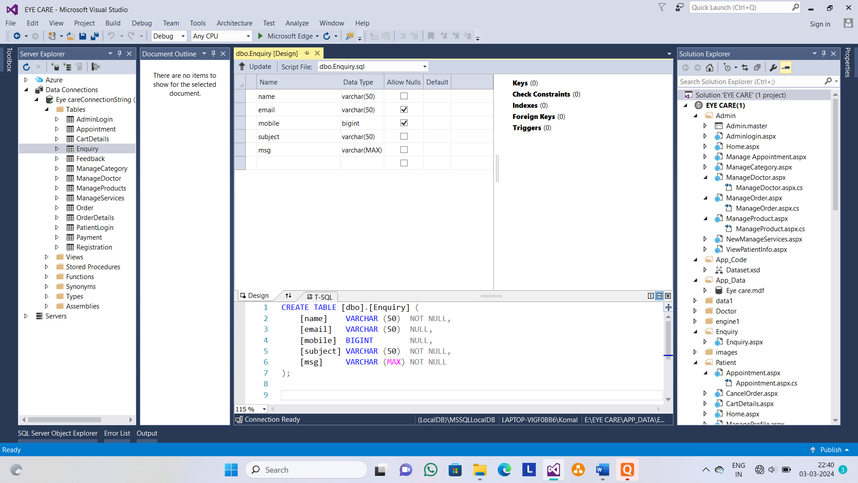

**Table Name:- CartDetails**

**Design View:-**

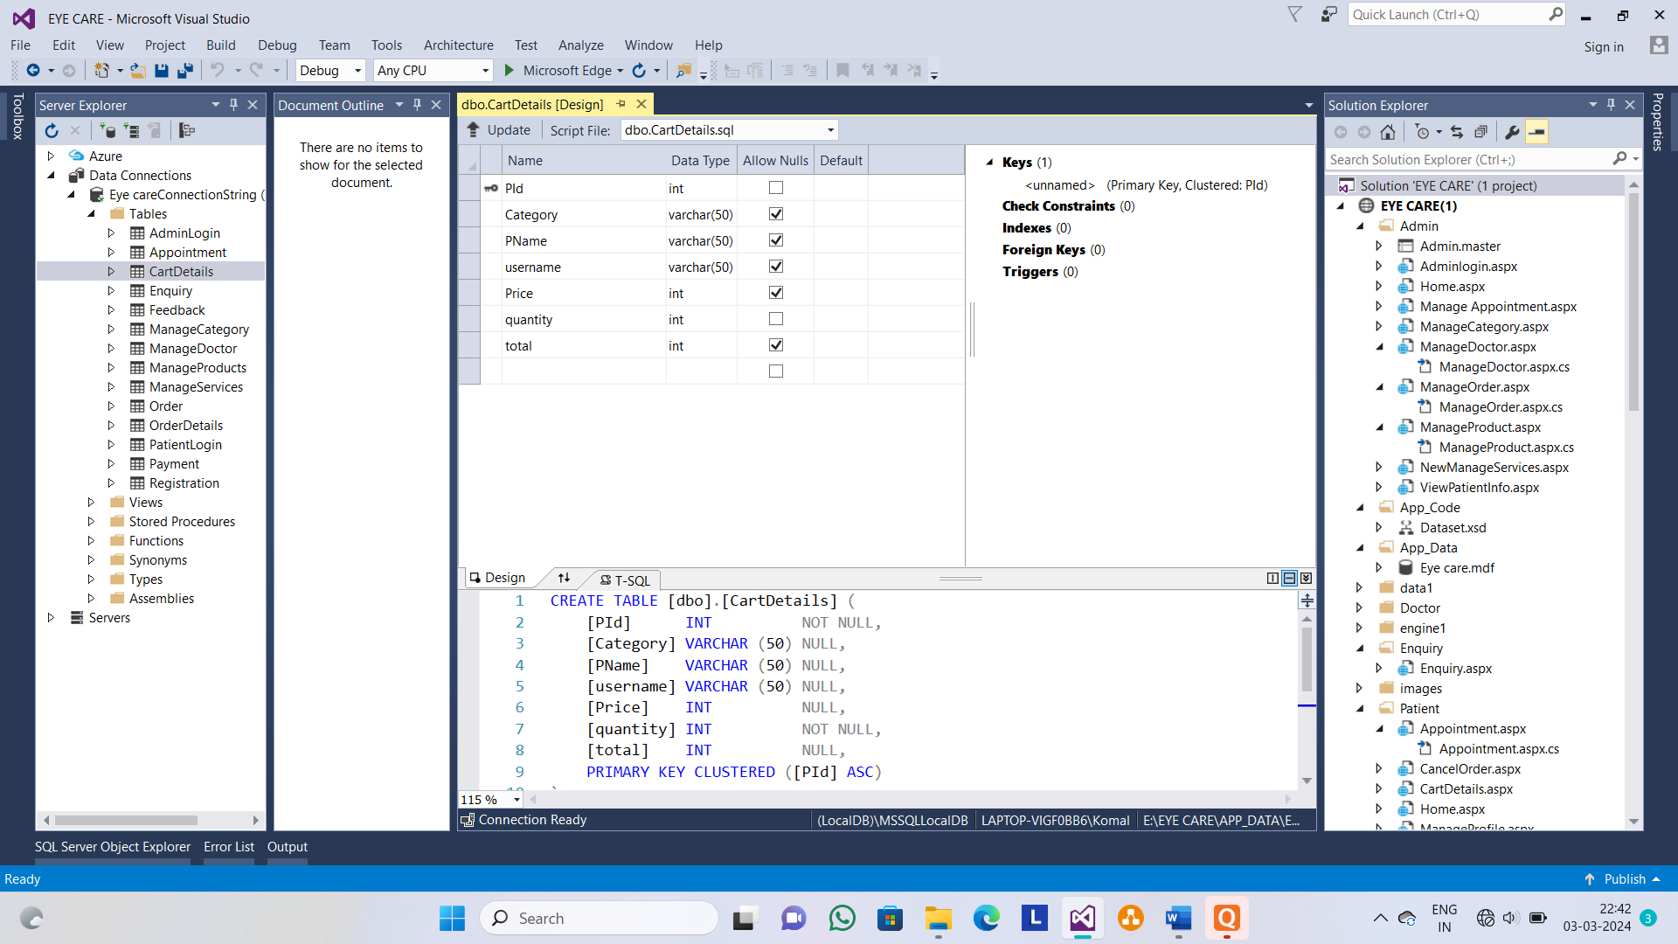

**Table name:- Admin**

**Design View:-**

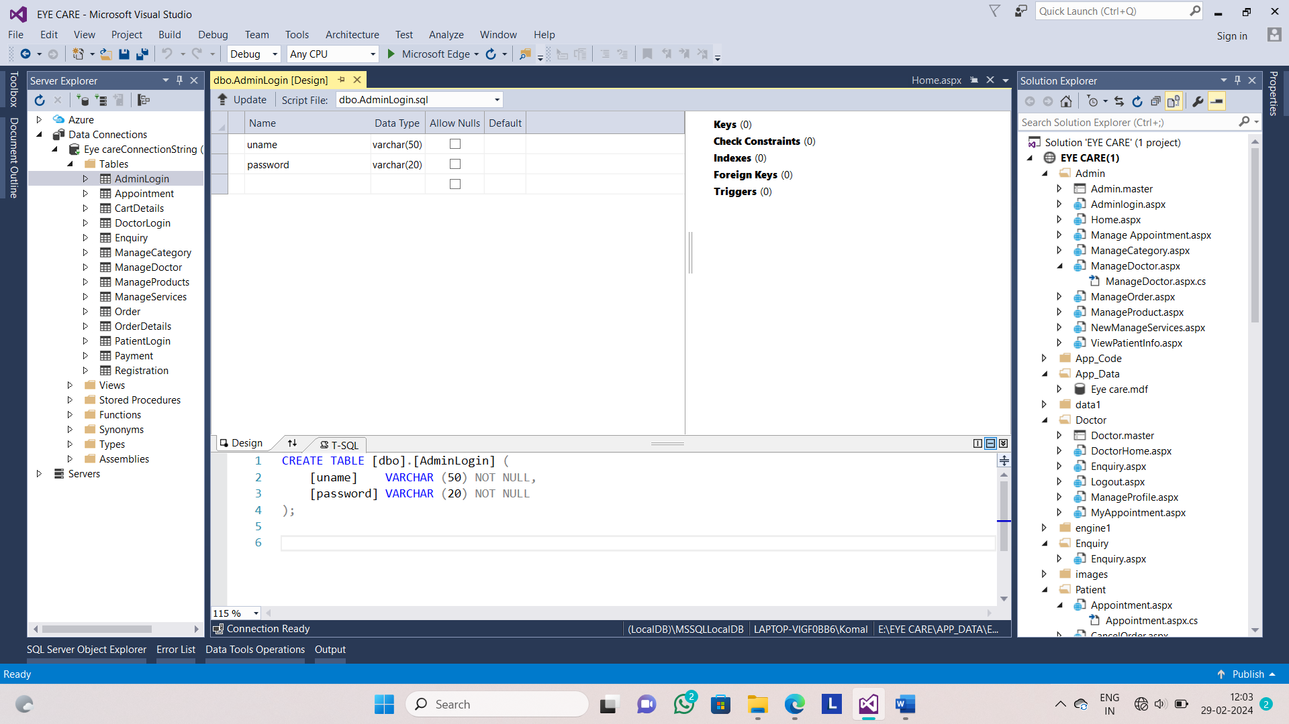

**Home Page:-**

Home page of the website**.**

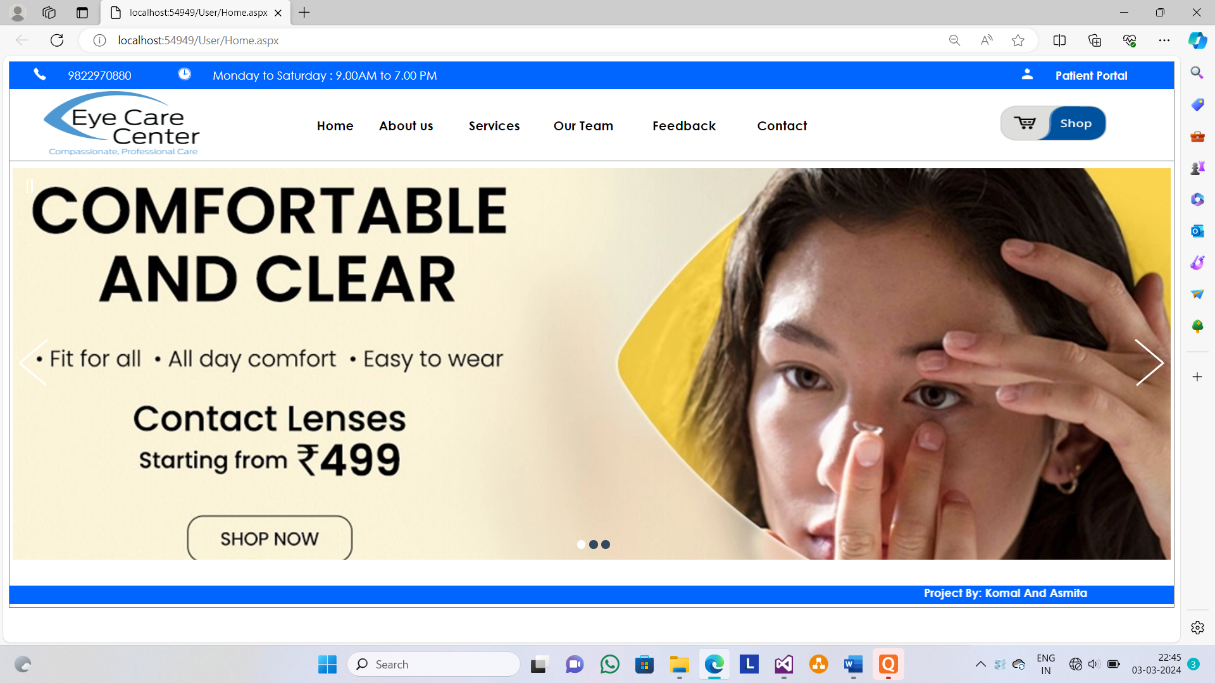

**About Us:-**

This page shows About us of EYE CARE.

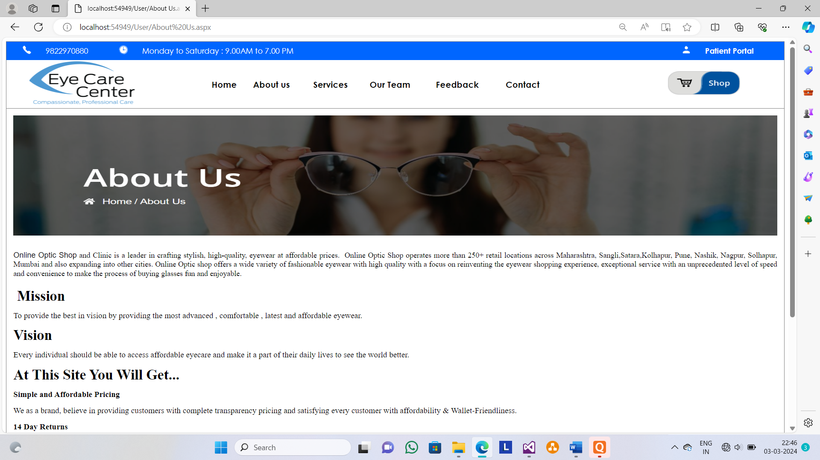

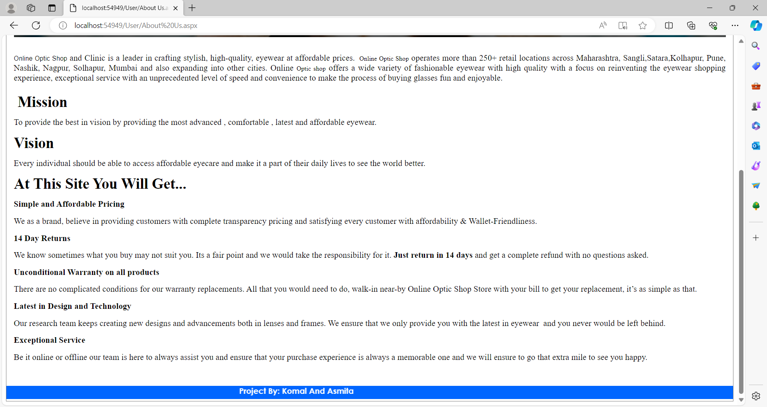

**Services:-**

This page shows all services provide by EYE CARE.

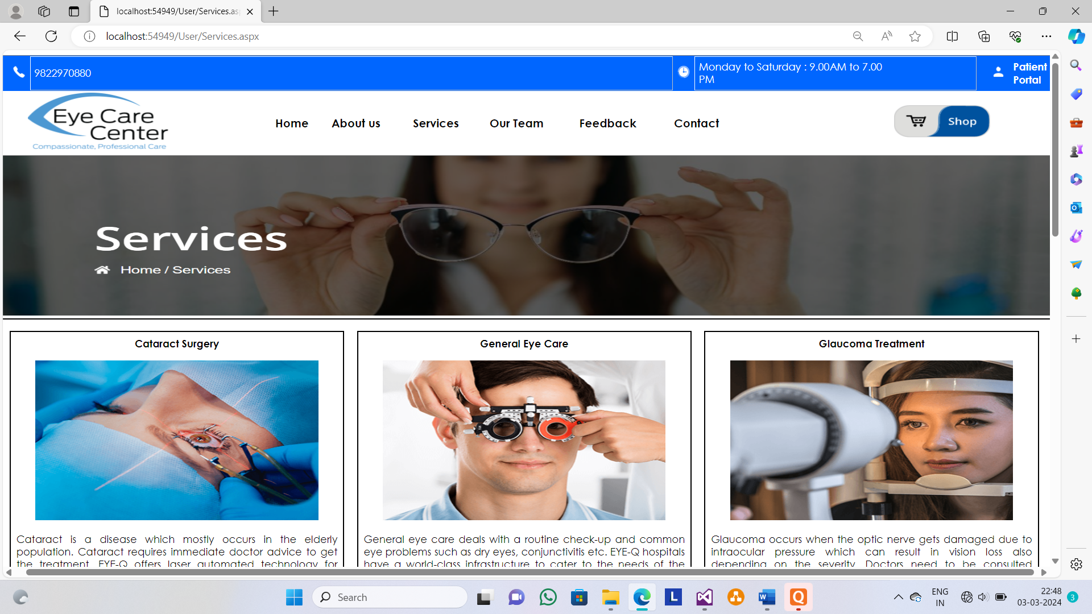

**Our Team:-**

This page shows all doctors which provided by EYE CARE

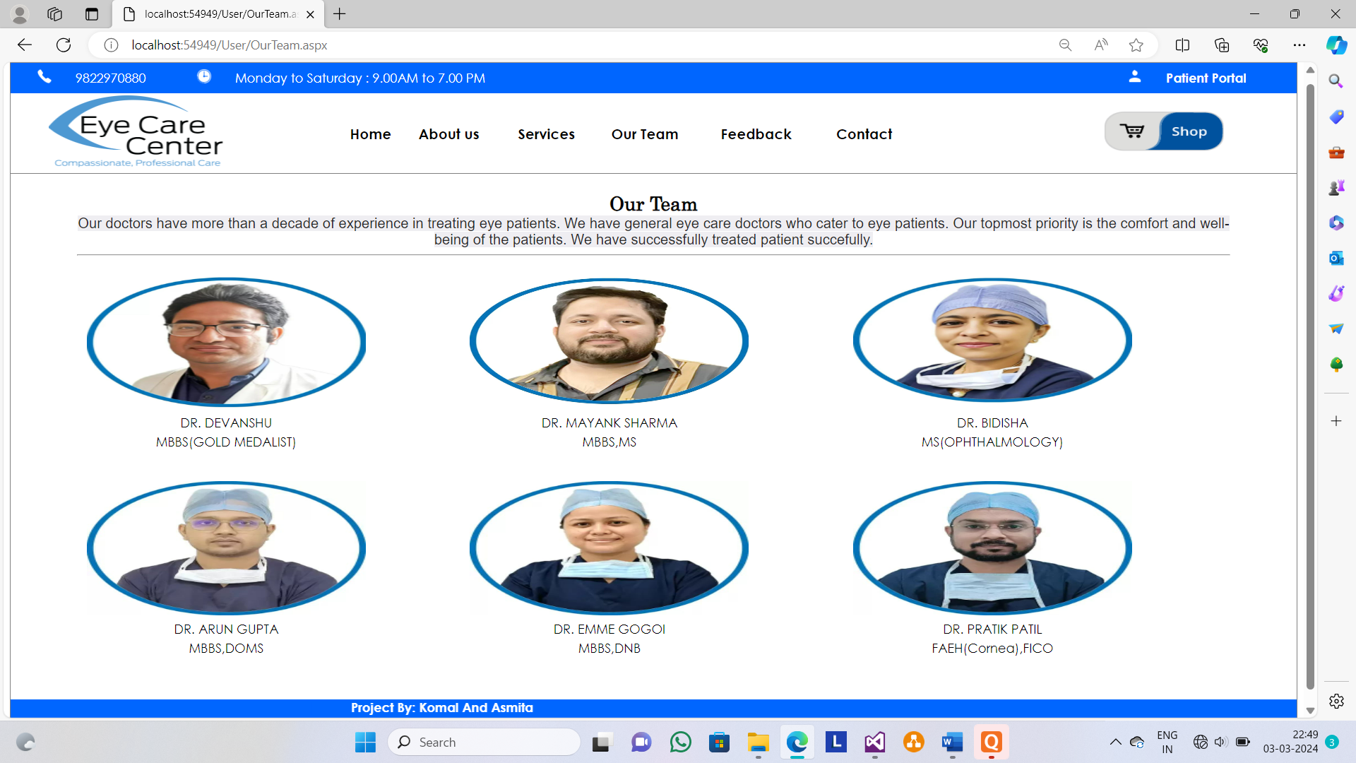

**Contact Us:-**

This page shows contact us of EYE CARE .

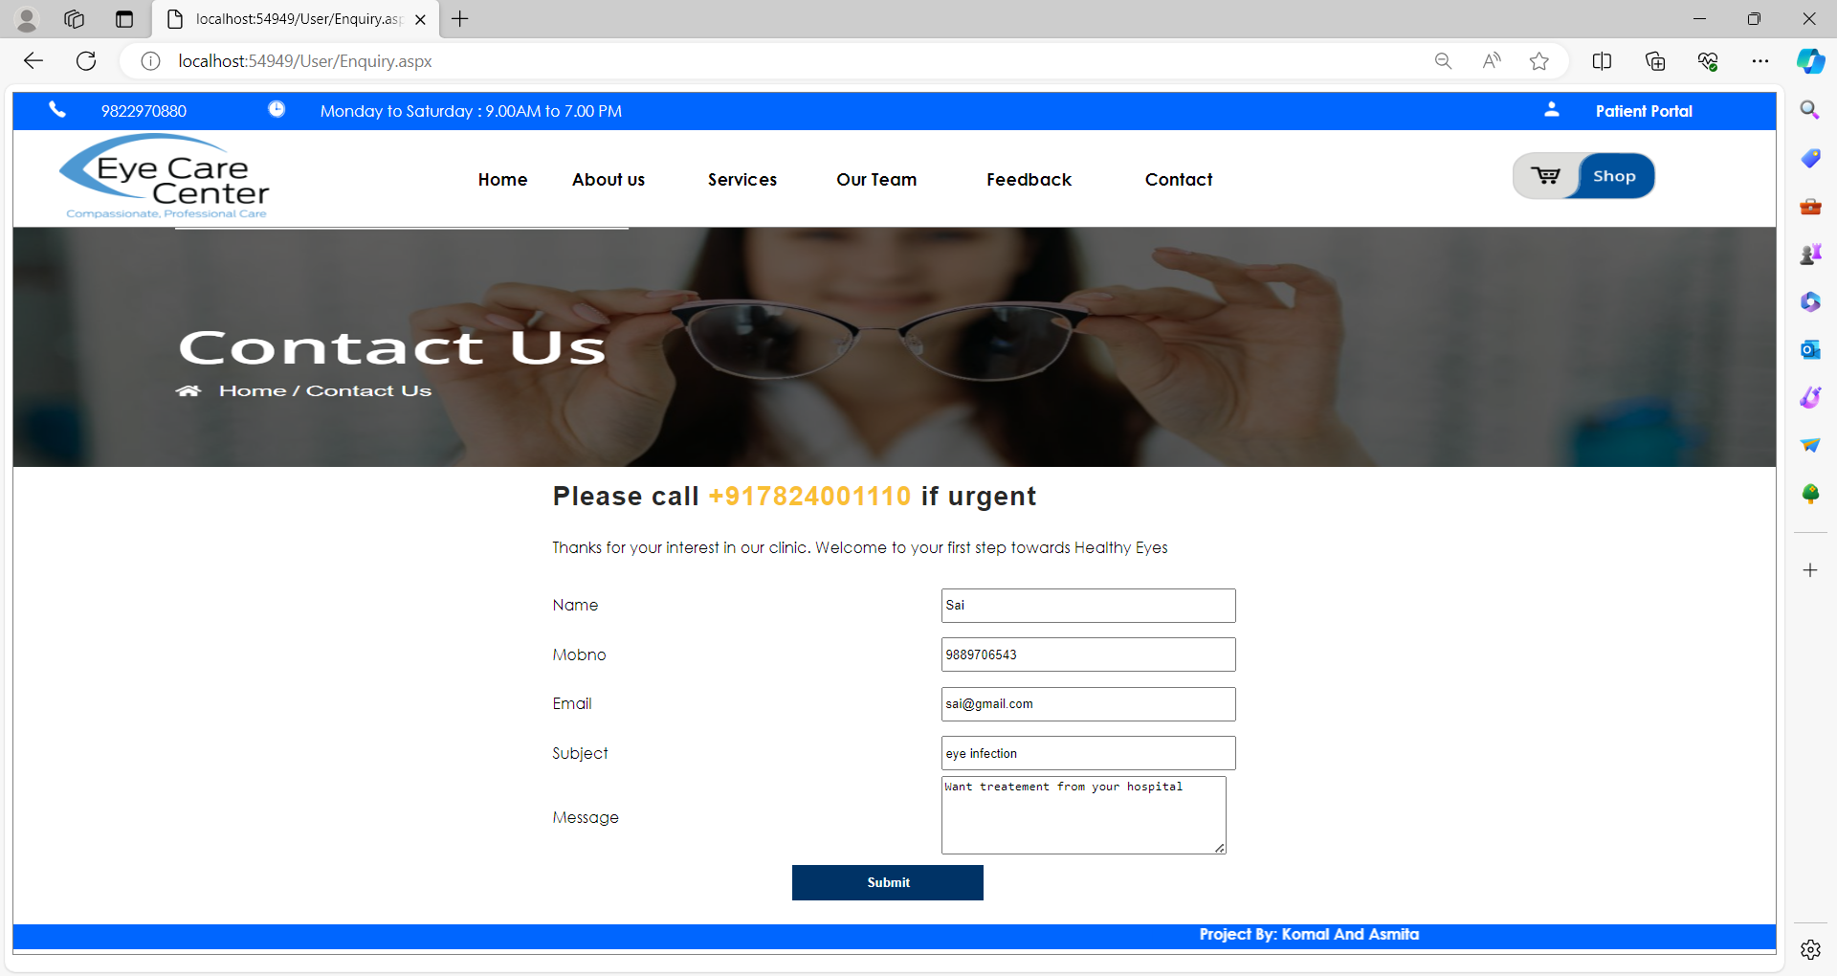

**Registration:-**

This page shows Registration form to patient of EYE CARE.

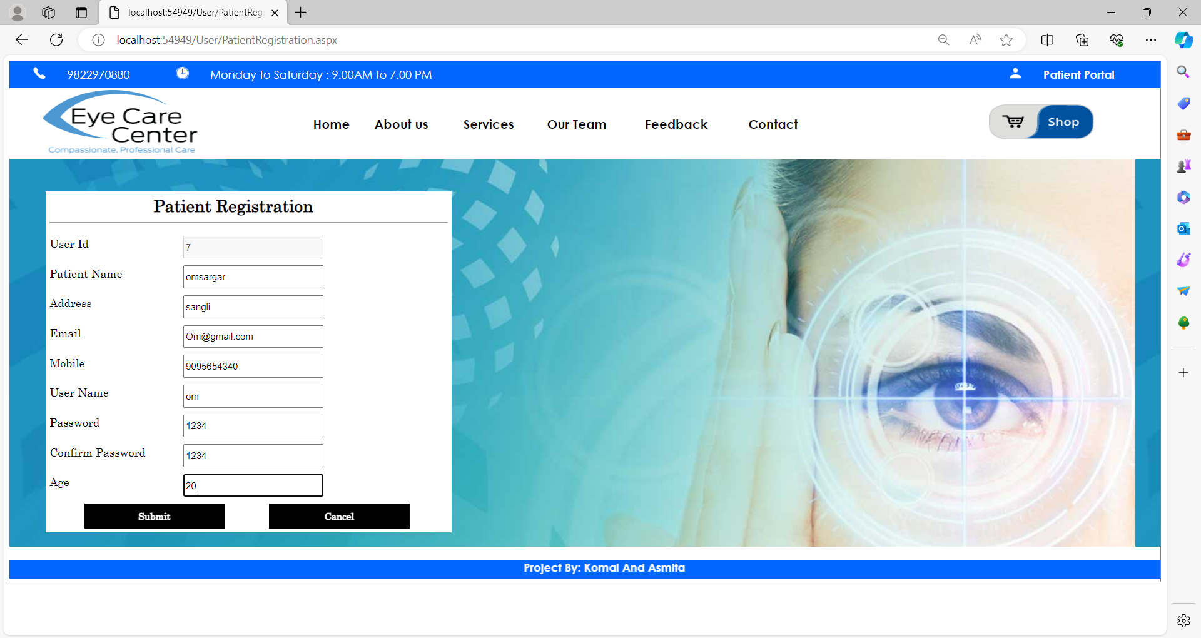

**Login:-**

This page shows Login form to customer of EYE CARE.

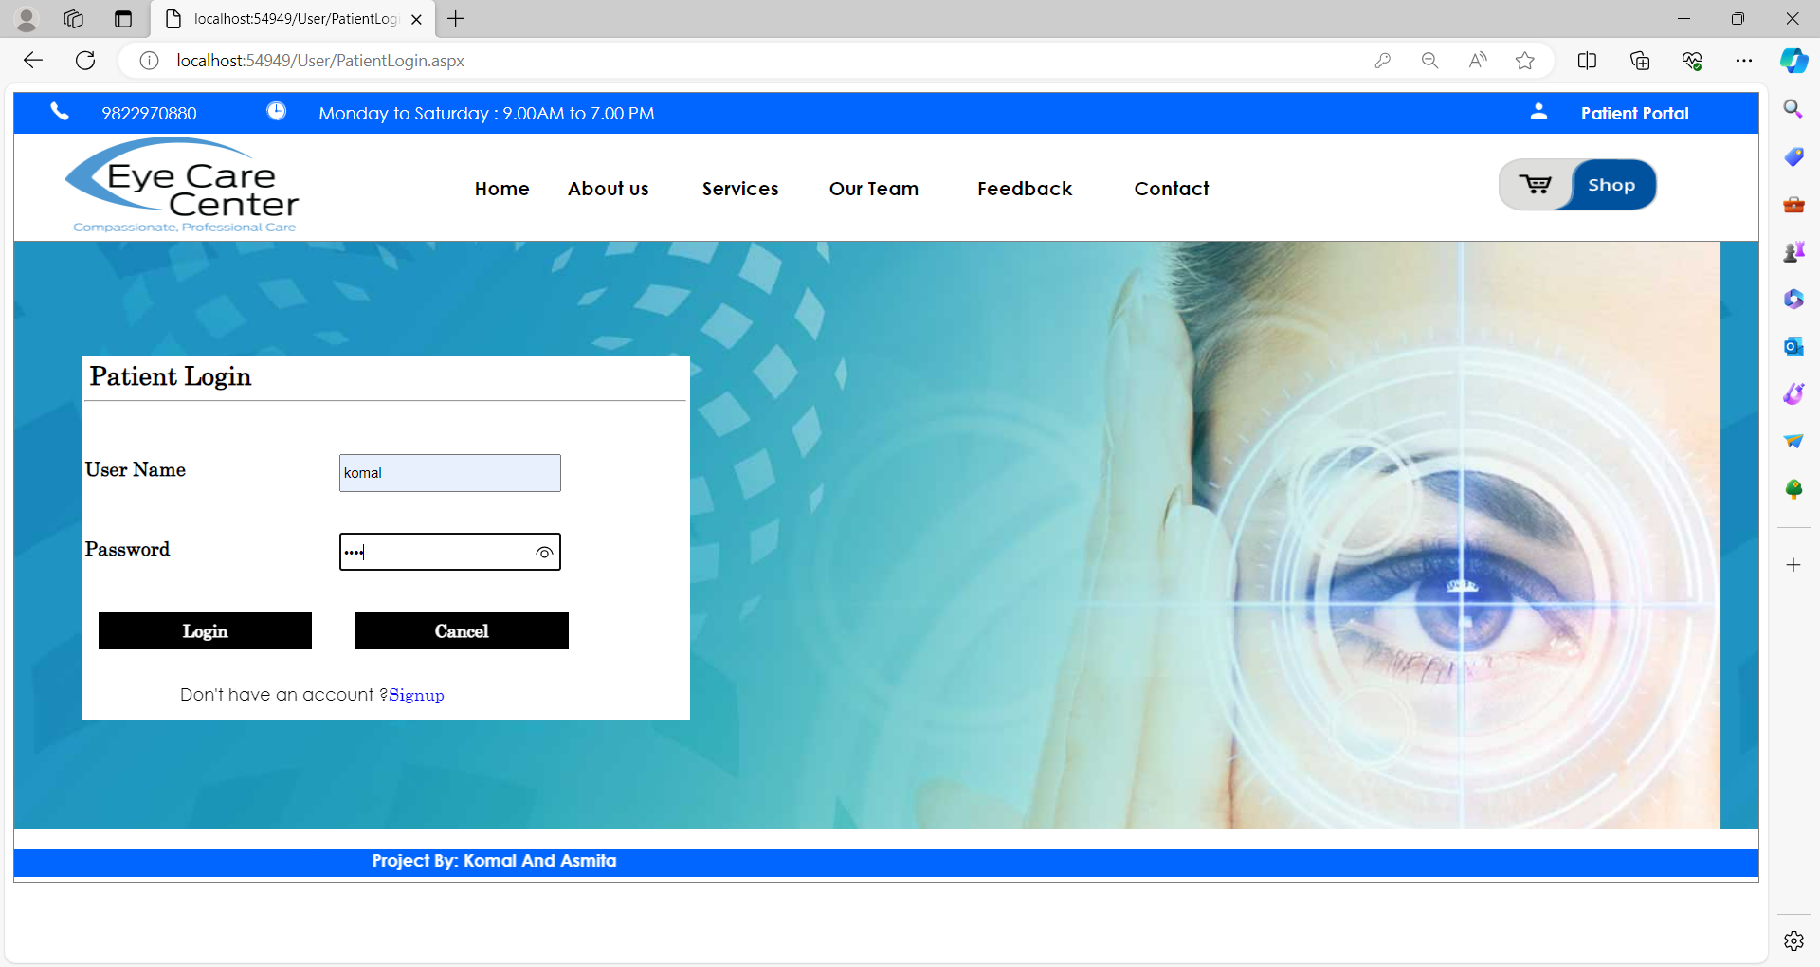

**Patient Home Page :-**

Home page of the Patient / Customer of website**.**

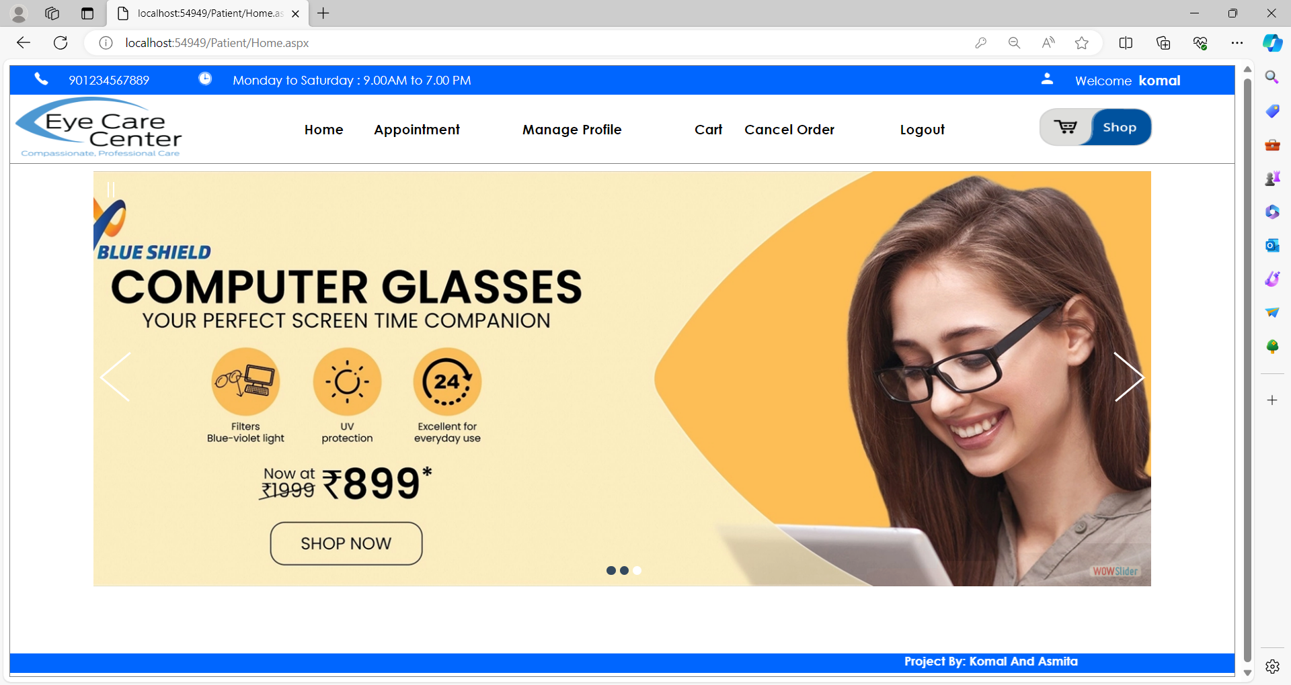

**Patient Appointment:-**

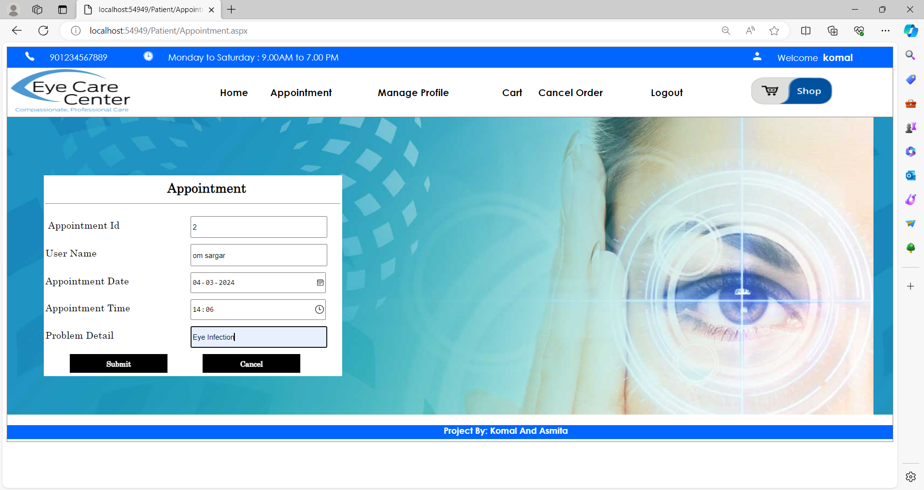

**Product Category:-**

This shows the product category page.

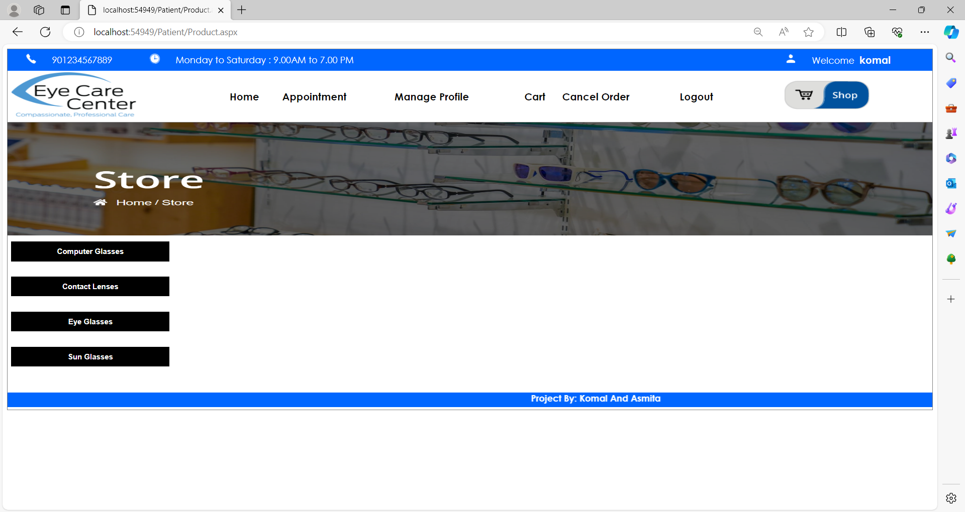

**Products:-**

This page shows all the product of eye care.

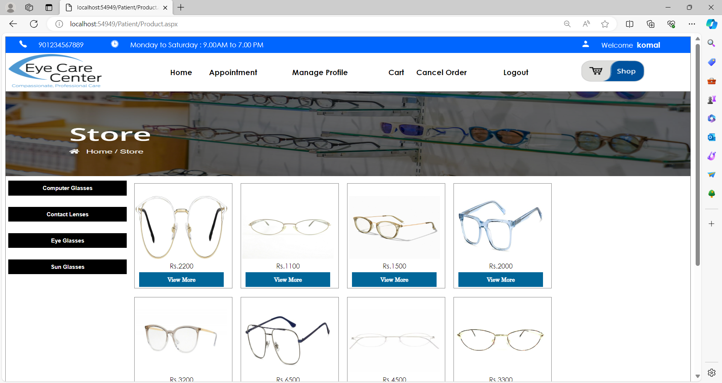

**Product Details:-**

This page shows all the details of a products.

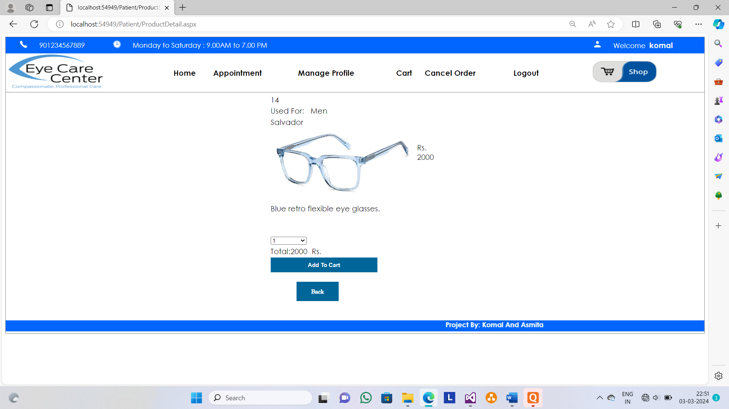

**Add To Cart:-**

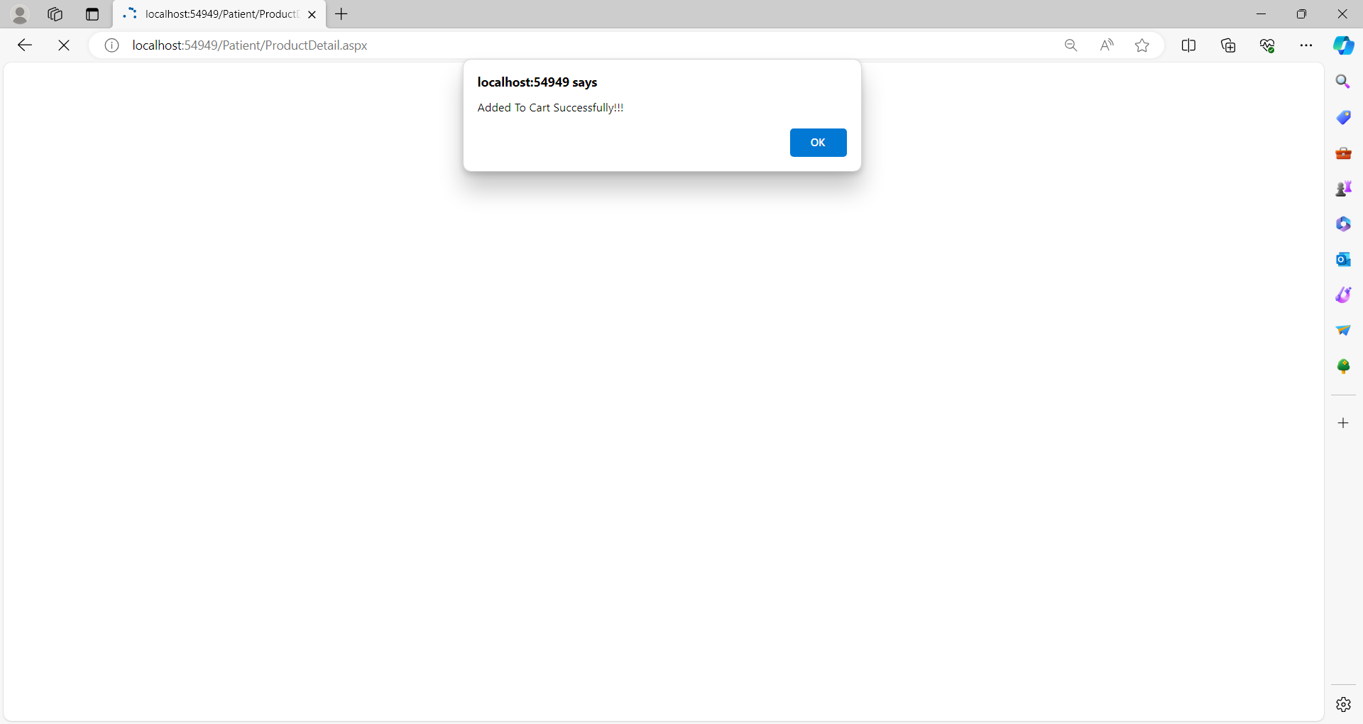

**Cart Page:-**

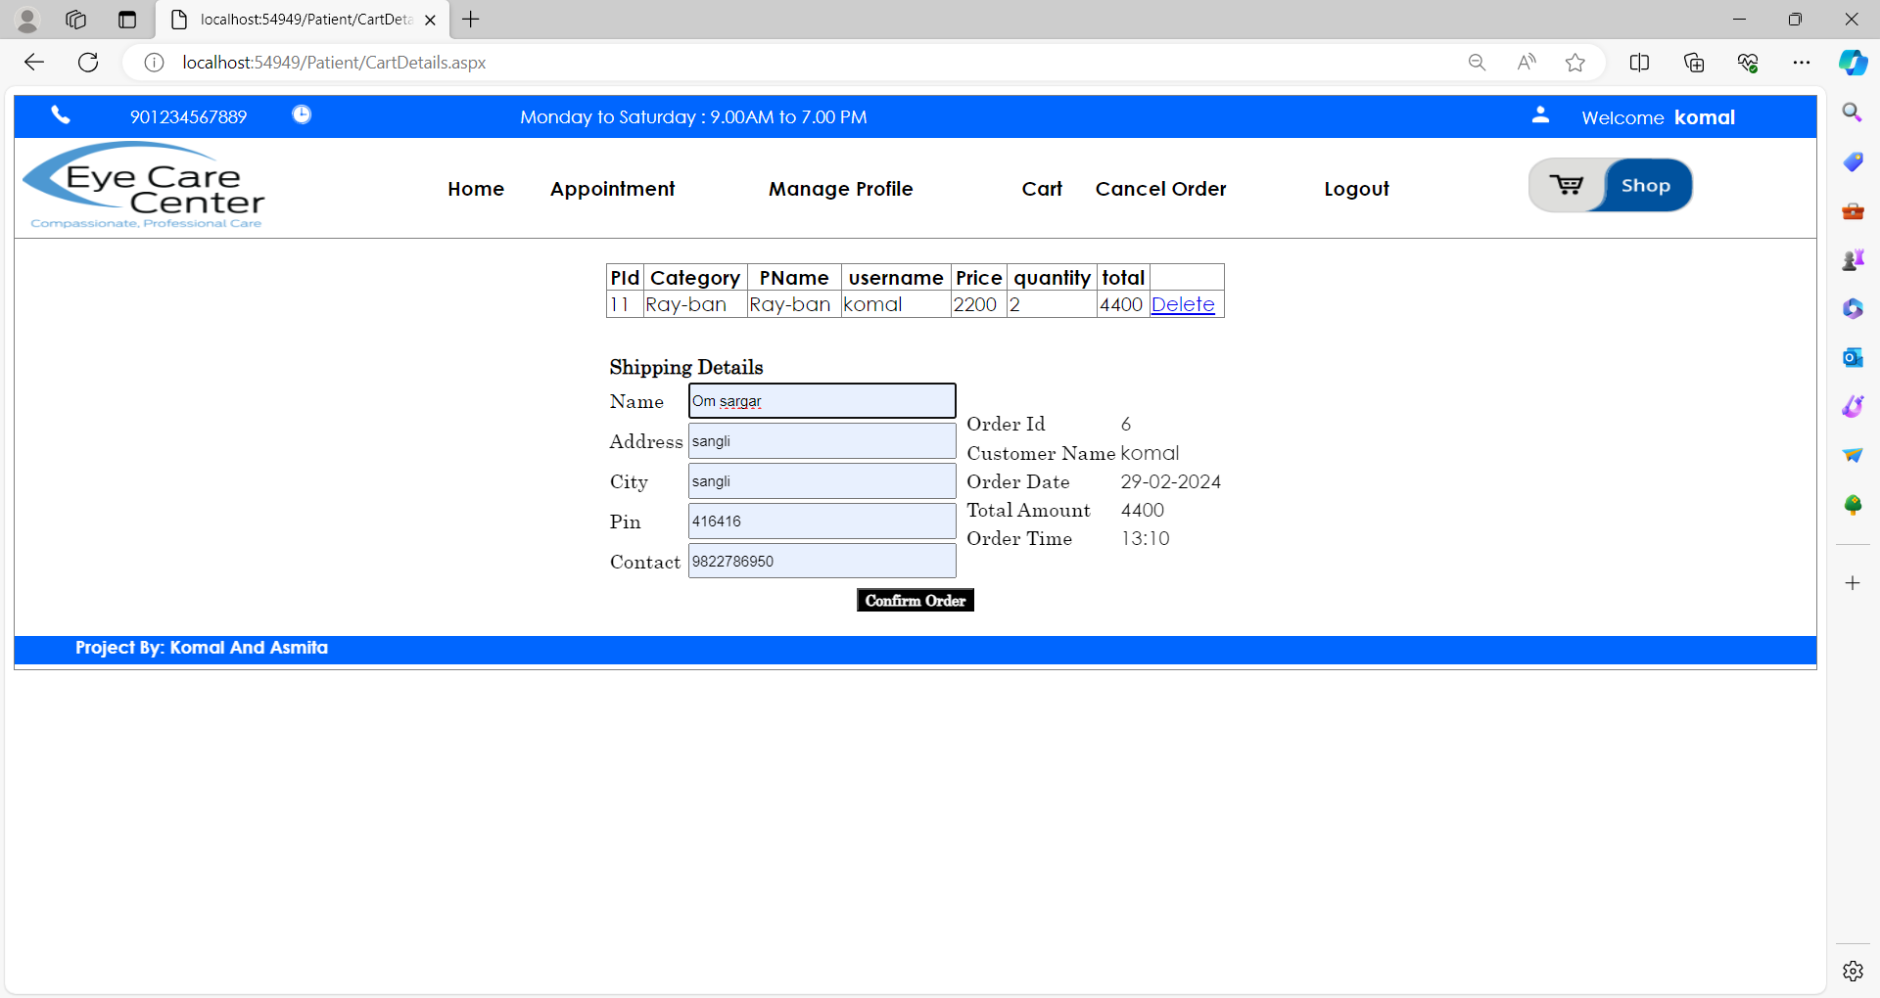

**Payment Details:-**

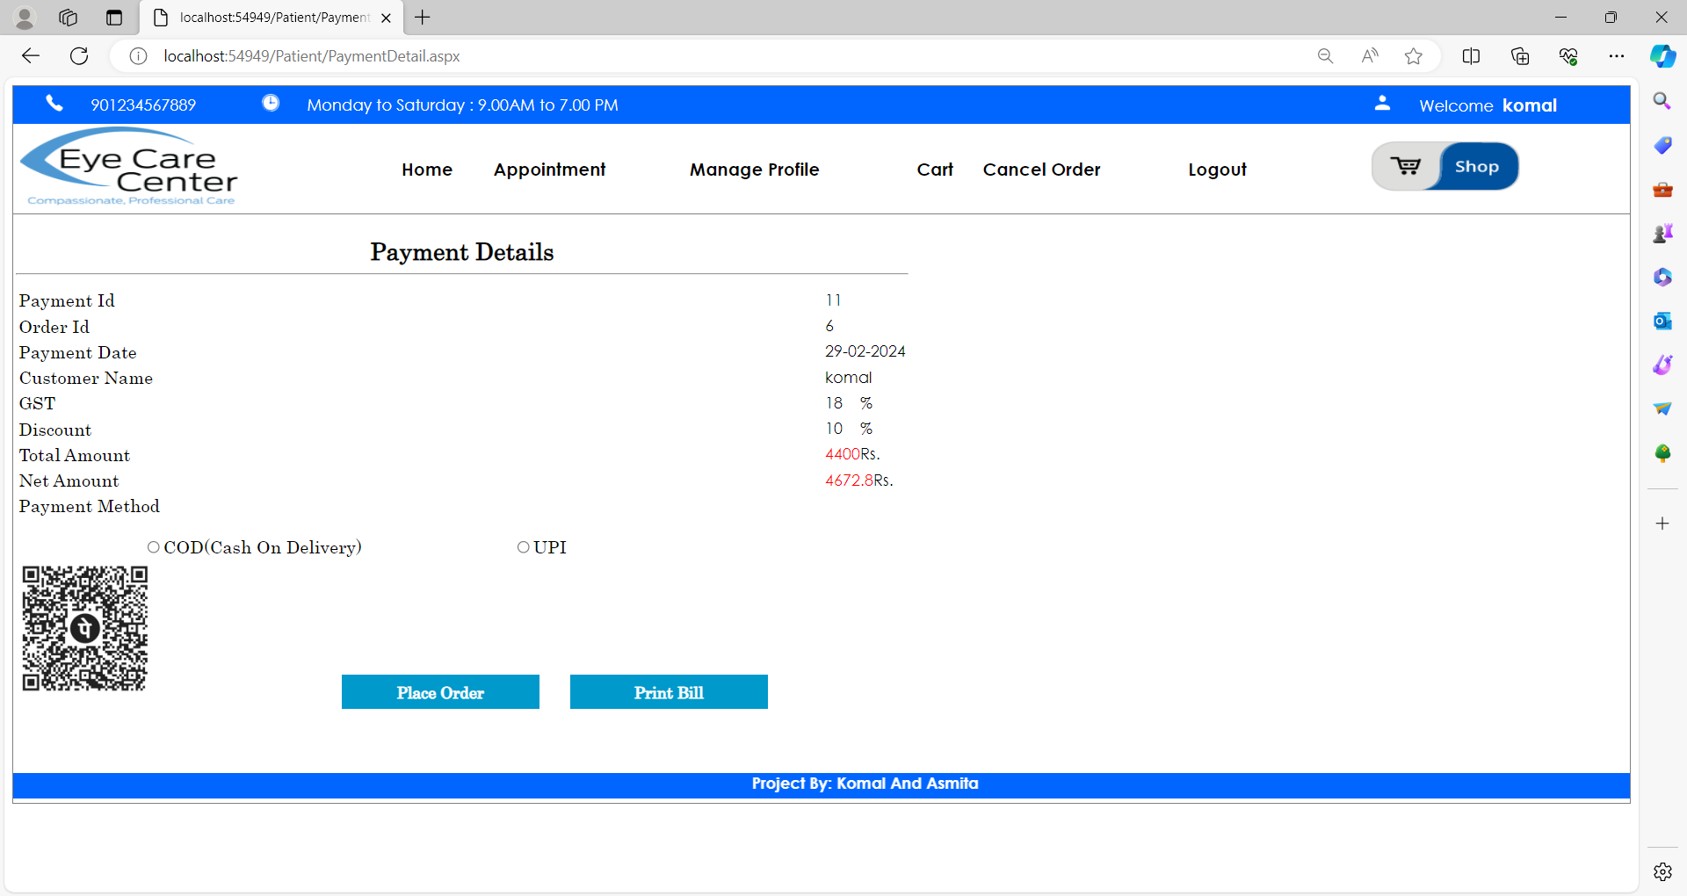

**Place Order :-**

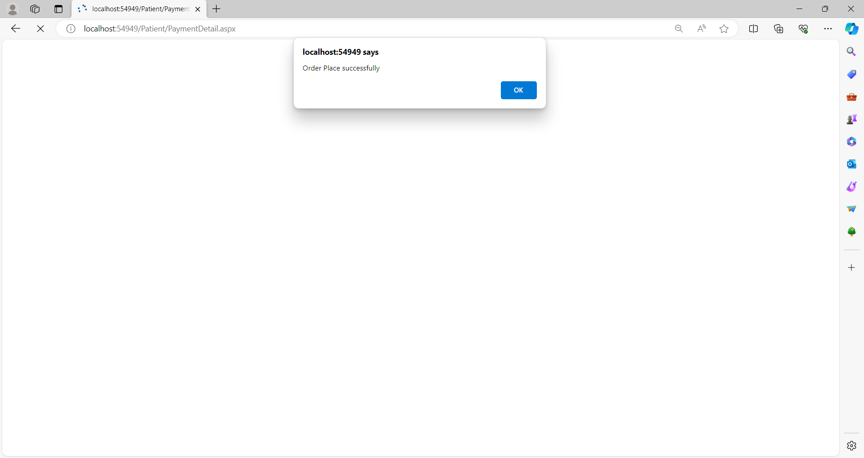

**Cancel Order :-**

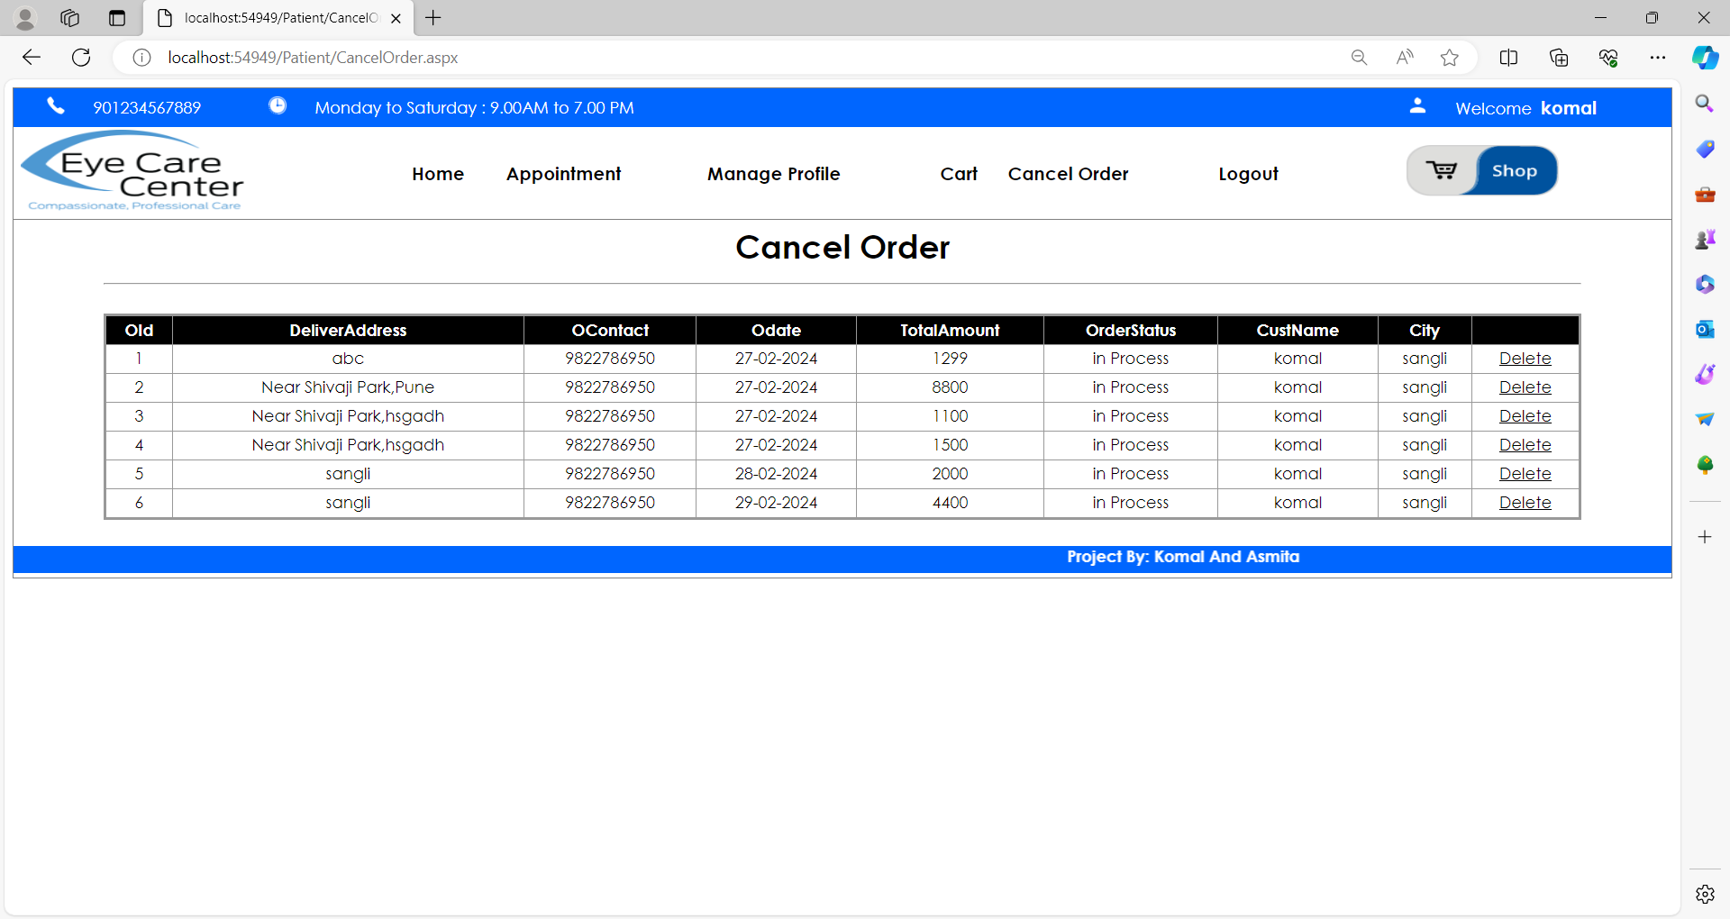

Admin Panel:

Admin Login:-

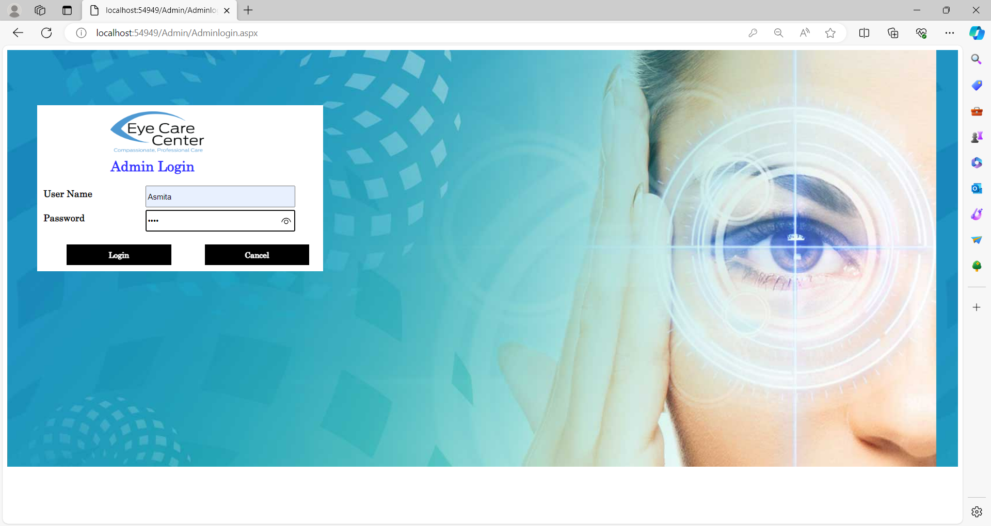

Manage Doctor:-

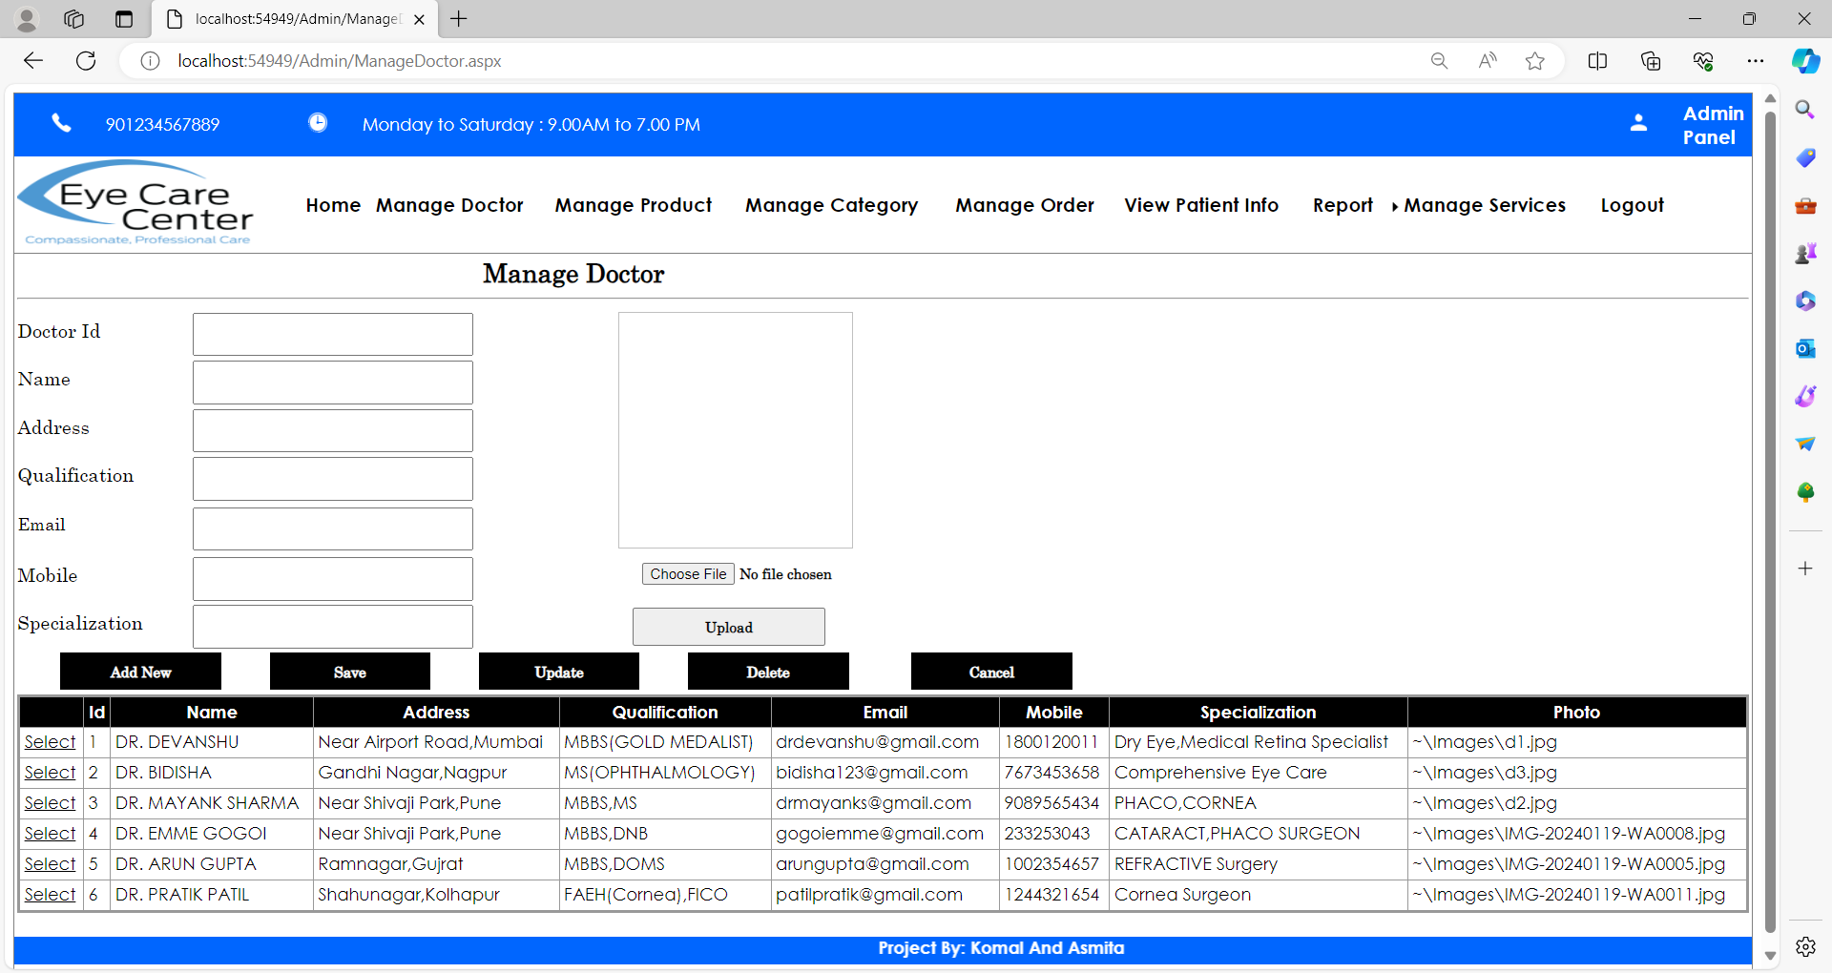

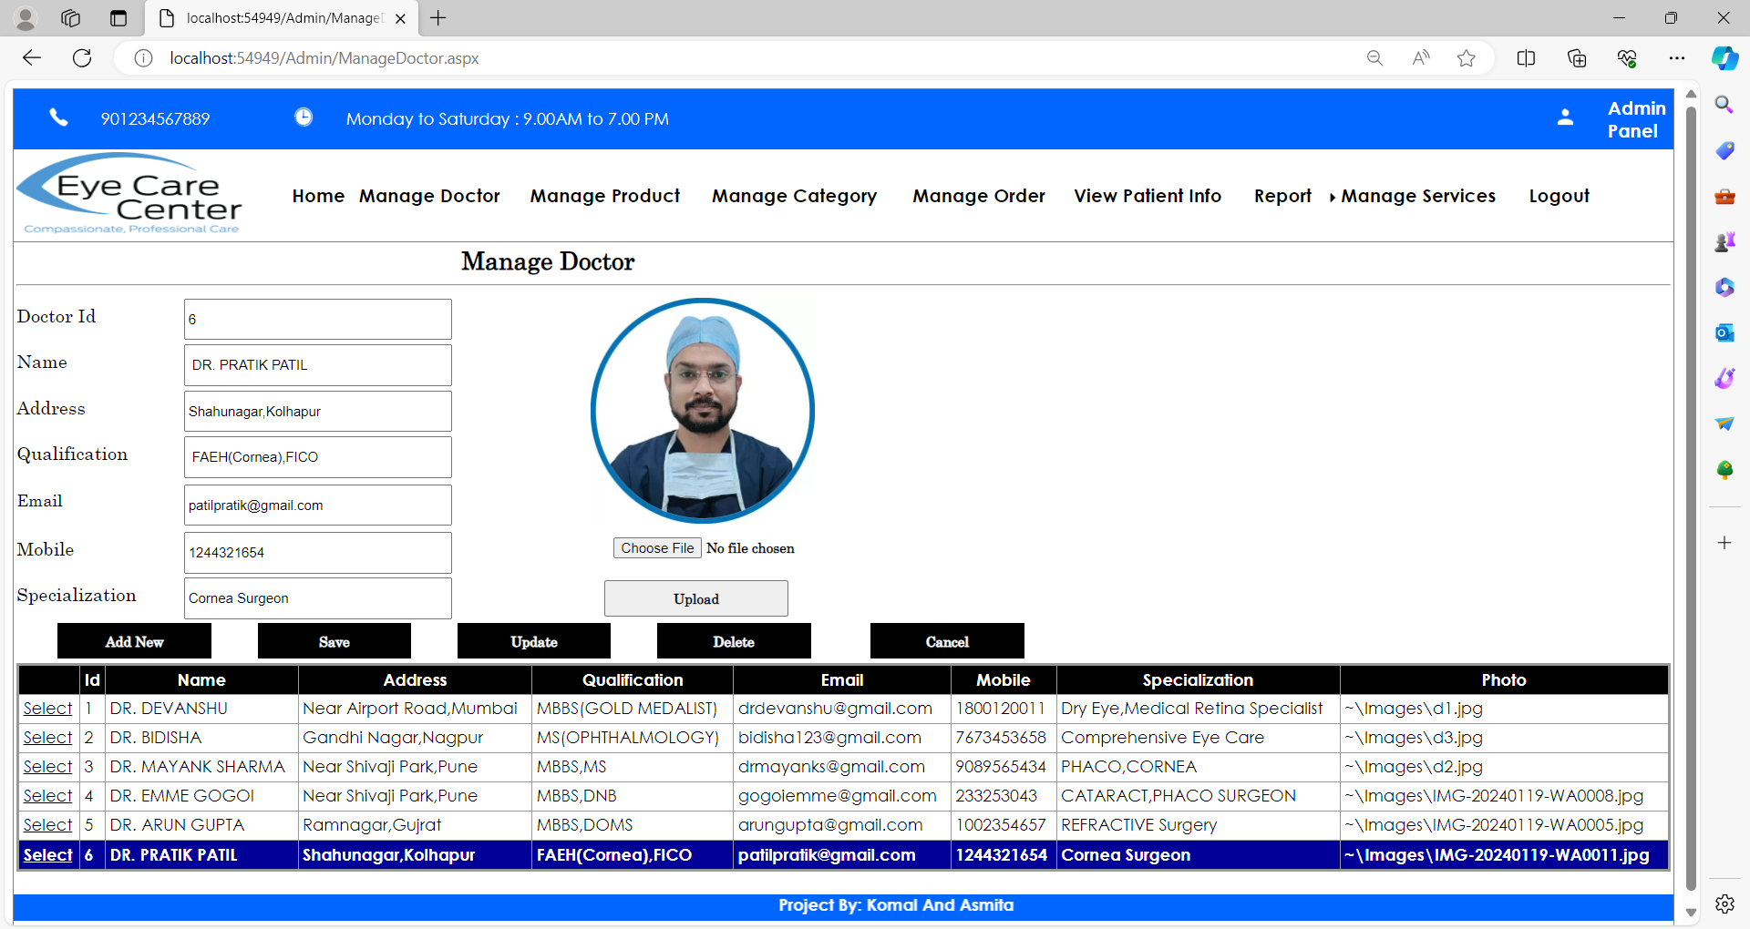

Manage Products:-

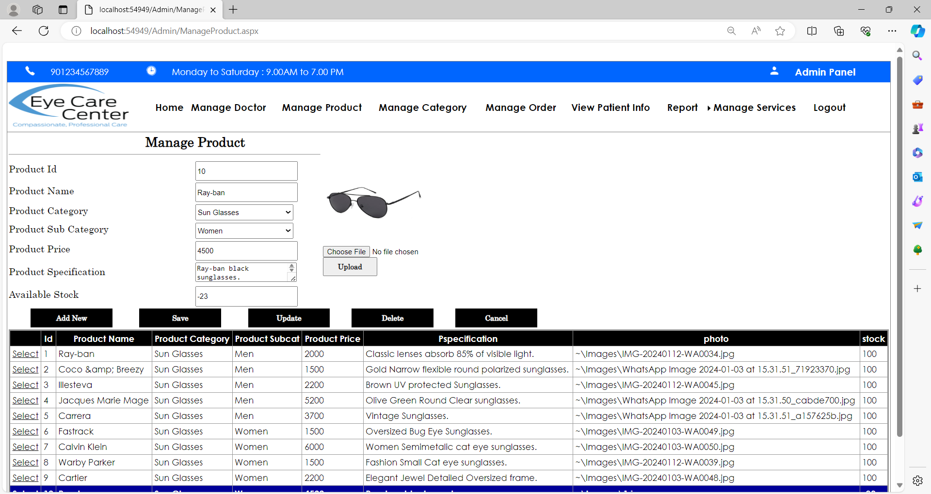

Manage Category:-

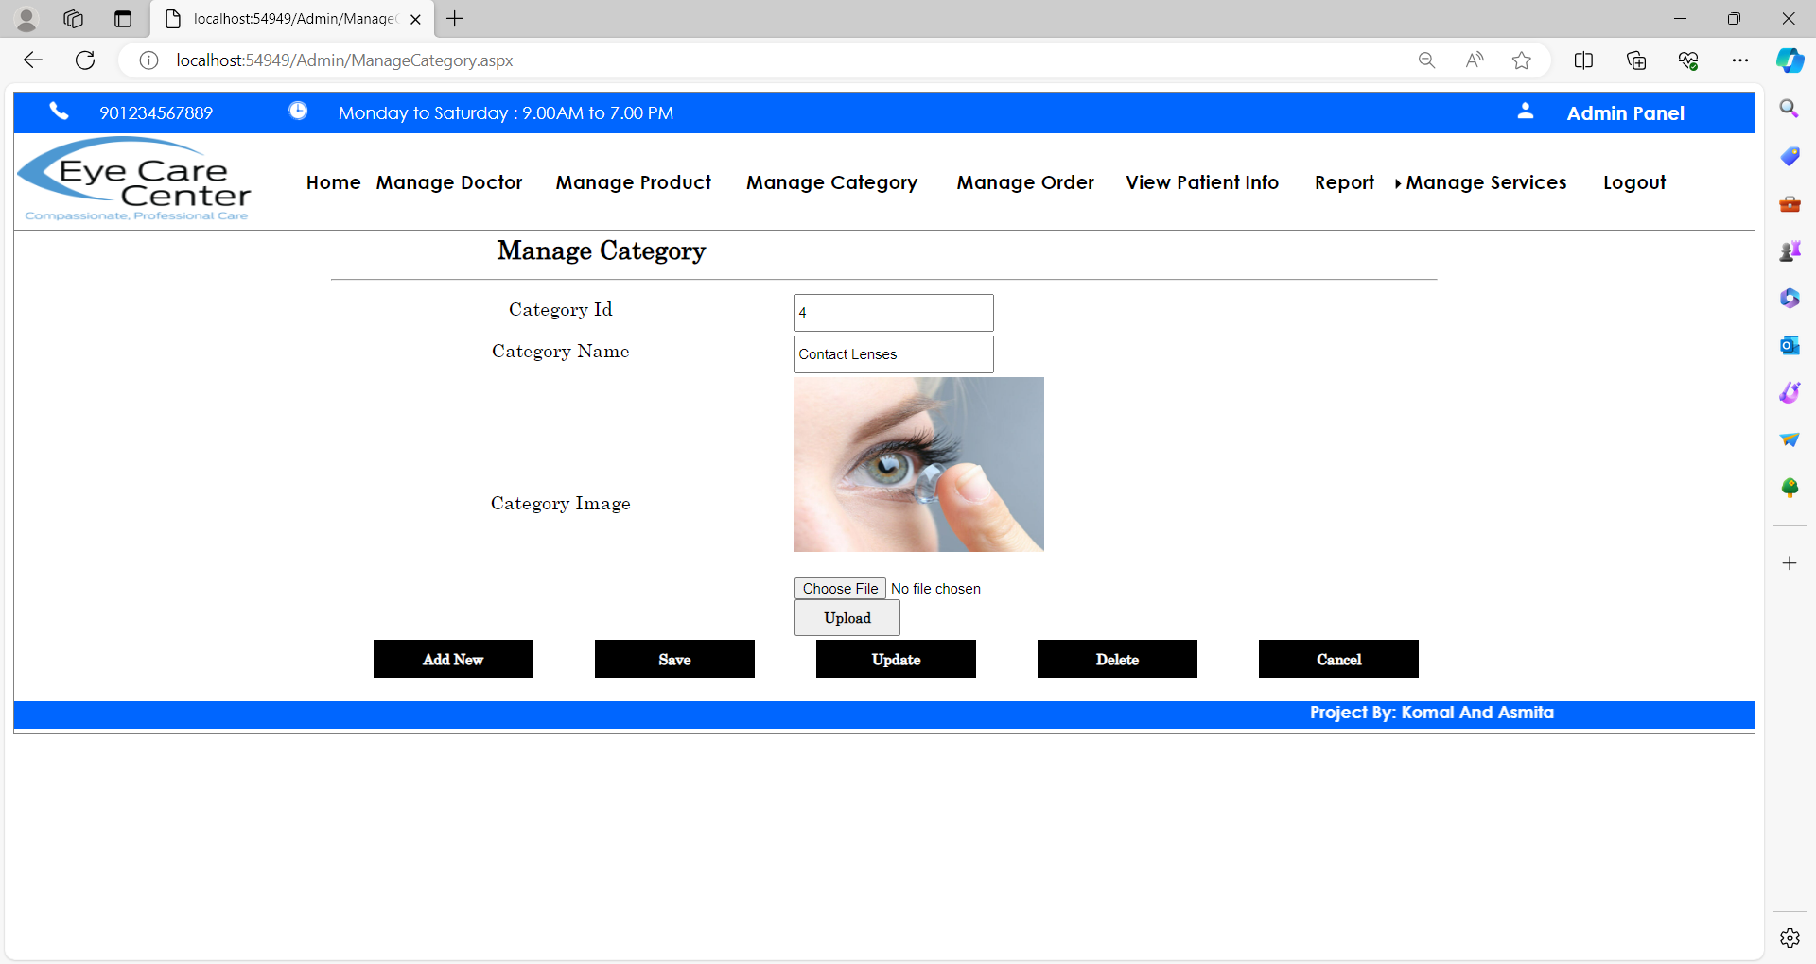

Manage Order:-

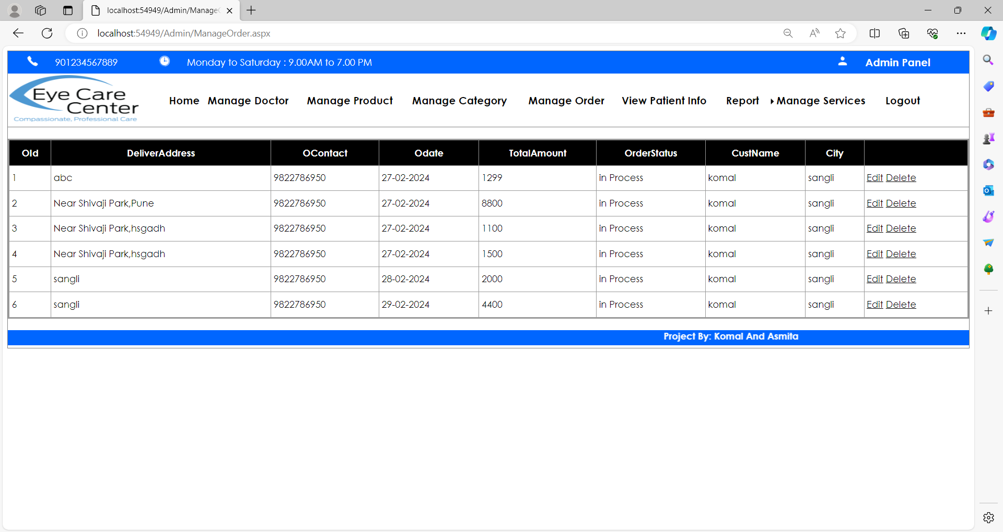

View Patient Information:-

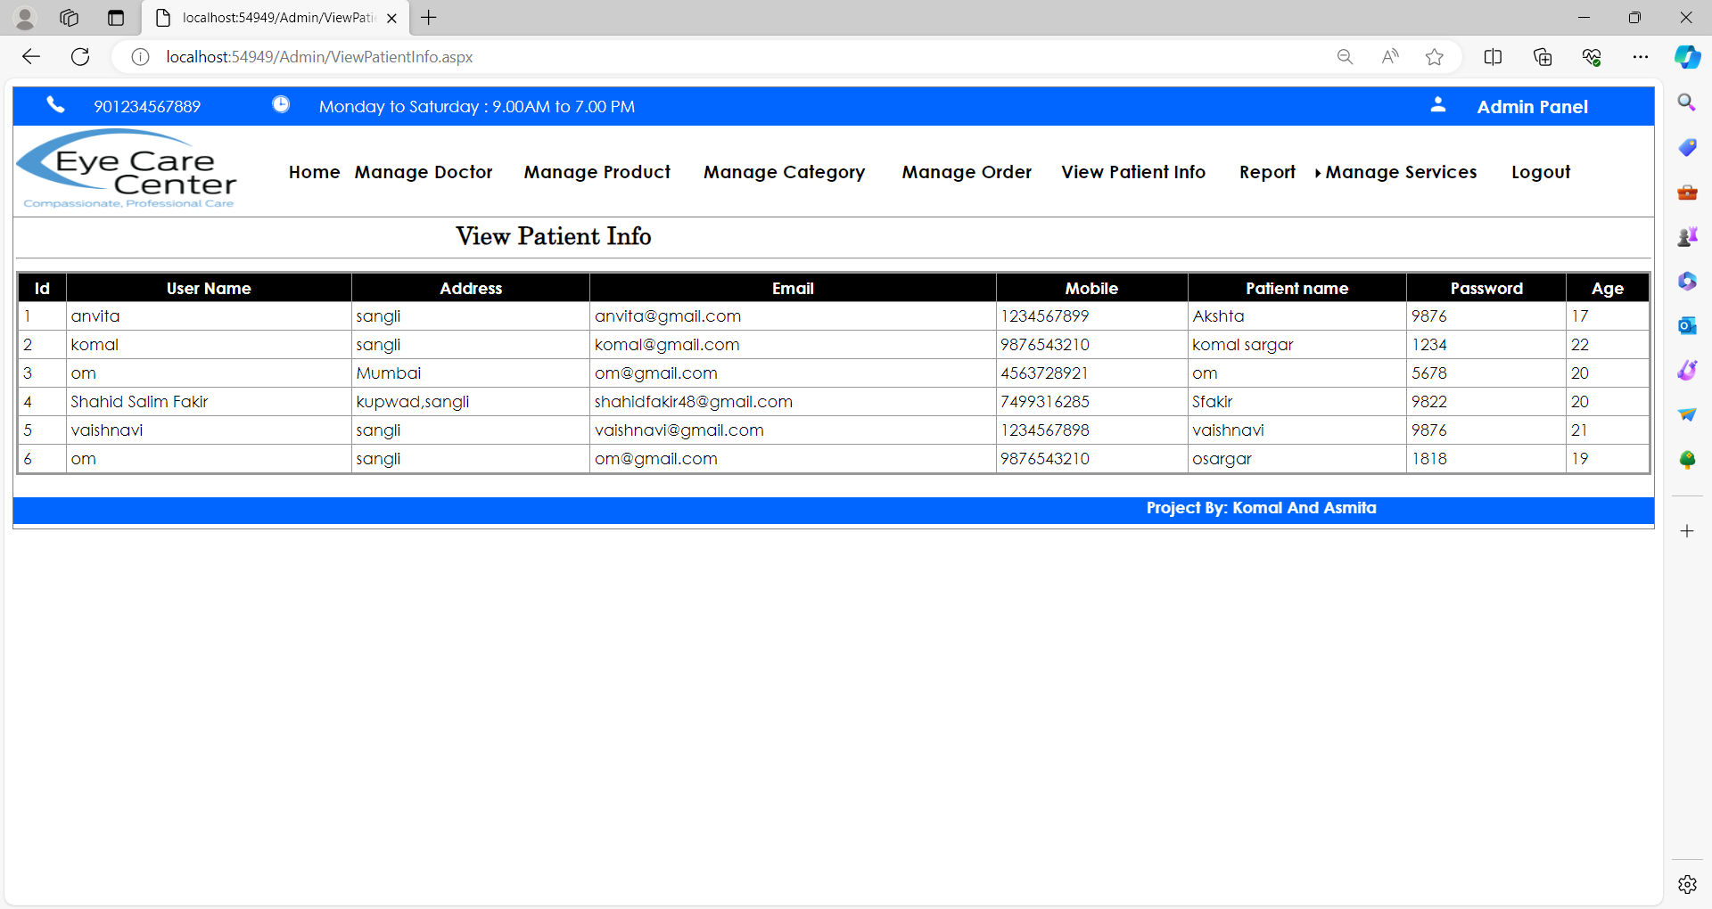

Manage Services:-

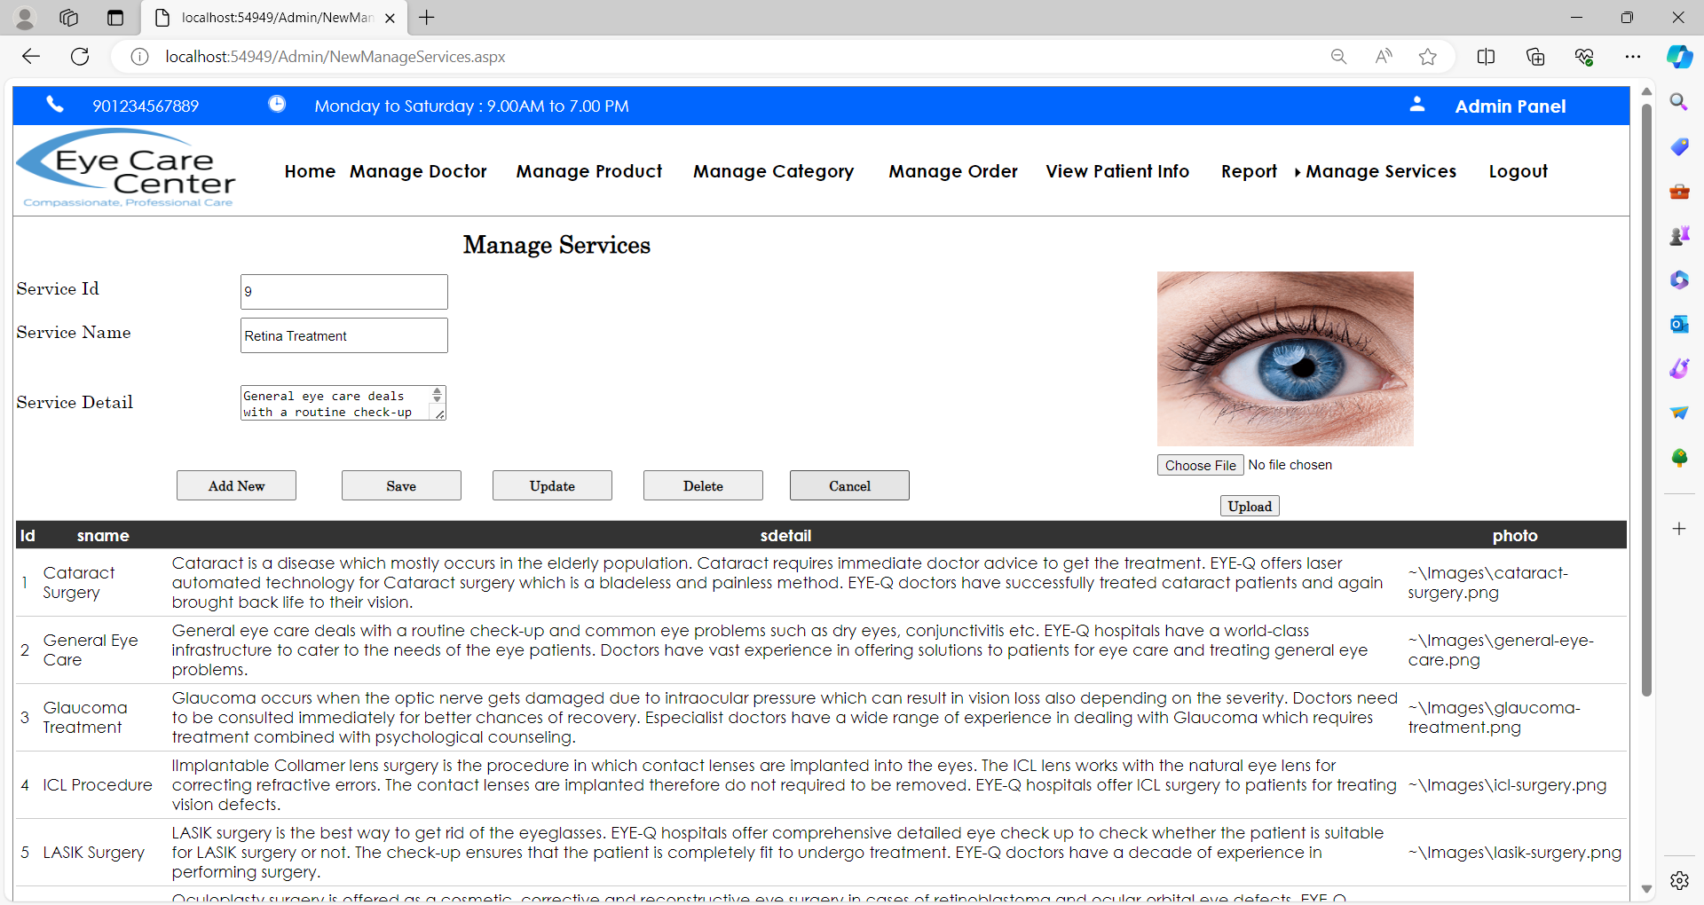

**Implementation:**

**System Requirement:-**

**• Hardware:**

* Processor : Intel core i5 & Above
* RAM : 8 GB
* Hard Disk : 40 GB.

**• Software:**

* Operating System : Windows 11 and above.
* IDE : Microsoft Visual Studio 2015.
* Project Platform : .NET.
* Framework : Framework 4.0.
* Front end : HTML,CSS, C#.
* Back End Tool: MY SQL
* Browser or Framework: Google Chrome, Microsoft edge

**User Guideline (User Manual):**

The Project consists of followings menu’s:

1. Home

2. Services

3. Products

4.Our Team

5. About Us

6. Contact Us

7. Registration

8. Feedback

1) Home:

A Home page is a primary webpage that a visitor will view when they navigate to a website.

2) Services:

A Service page is a webpage on website that shows our services in our website.

3) Products:

A Products page is a webpage where first you can see the categories in by clicking on the image button of category you can see the subcategories after that you can see the product page where you get little bit information of products in this page, we provided the view more button to see the overall information of selected product.

4)Our Team:

An Our Team page is a webpage on website that shows our doctors team.

5) About Us:

An About Us page is a webpage on website that tells your reader all about you. It includes a detailed description covering all aspects of website.

6) Contact Us:

This page contains a form to contact us regarding any enquires.

7) Registration:

This is the registration page for patient where he can fill information about him and here patient can create his own username and password.

8) Feedback:

This is the feedback page where customer can give his valuable feedback and he can do complaint also.

Output:

Category Reports:-

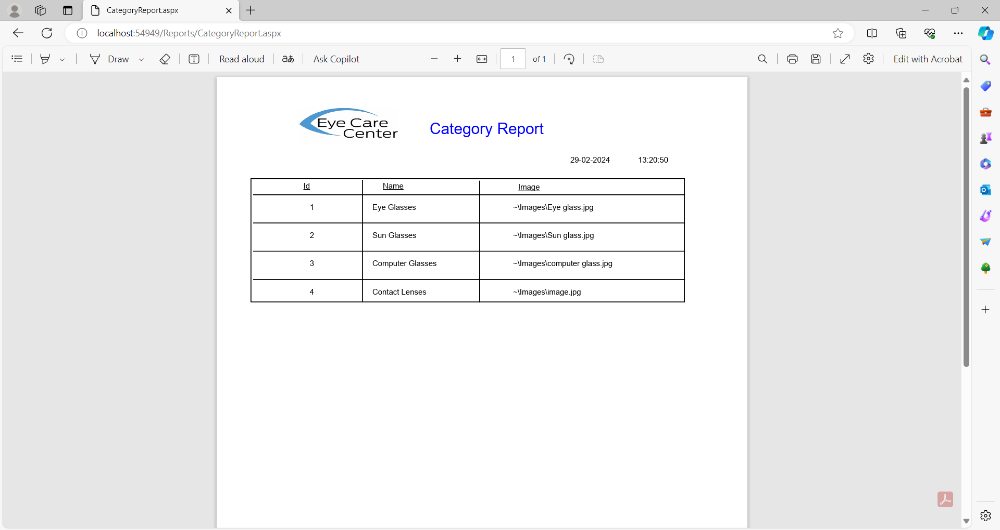

Product Report:-

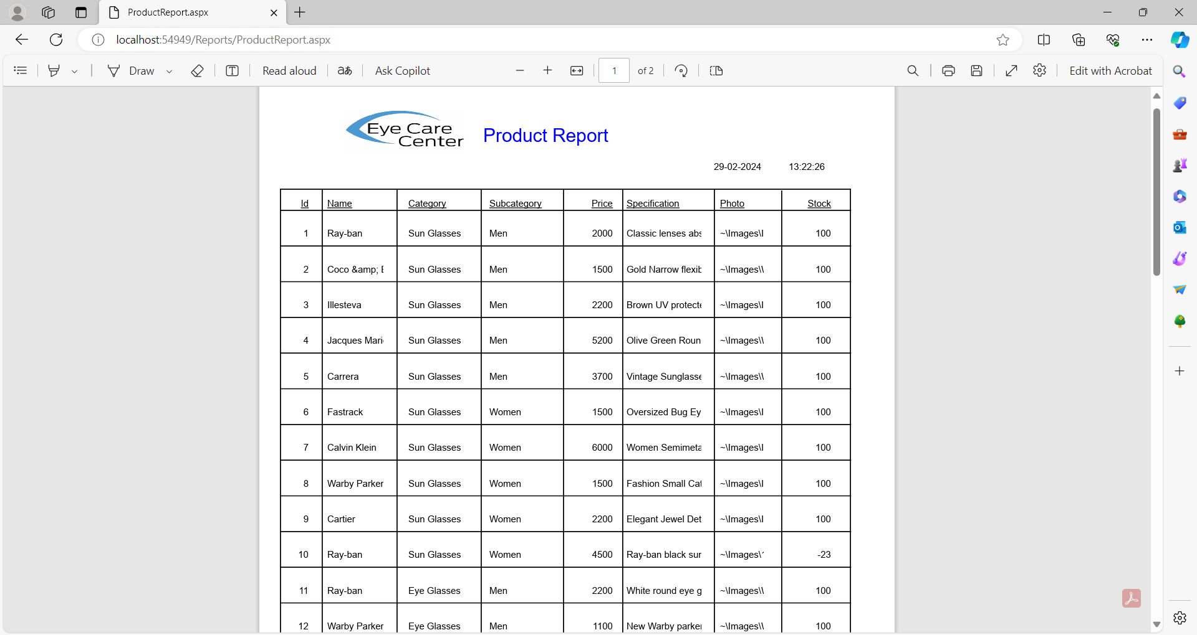

Enquiry Report:-

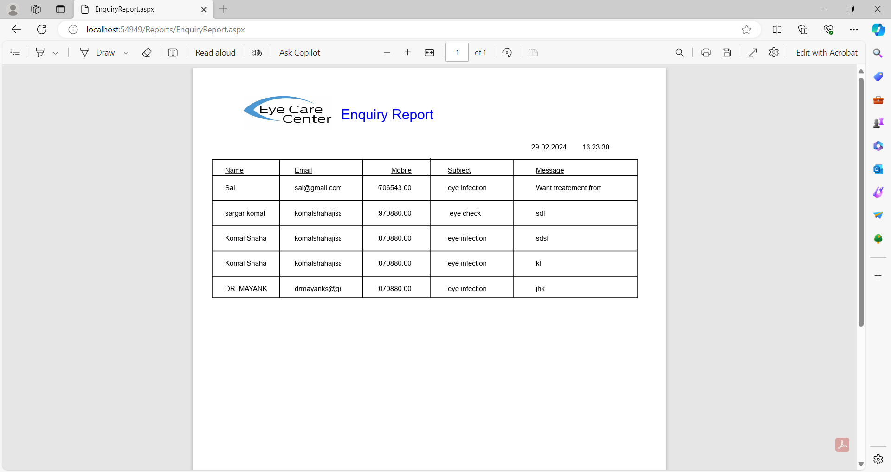

Doctor Report:-

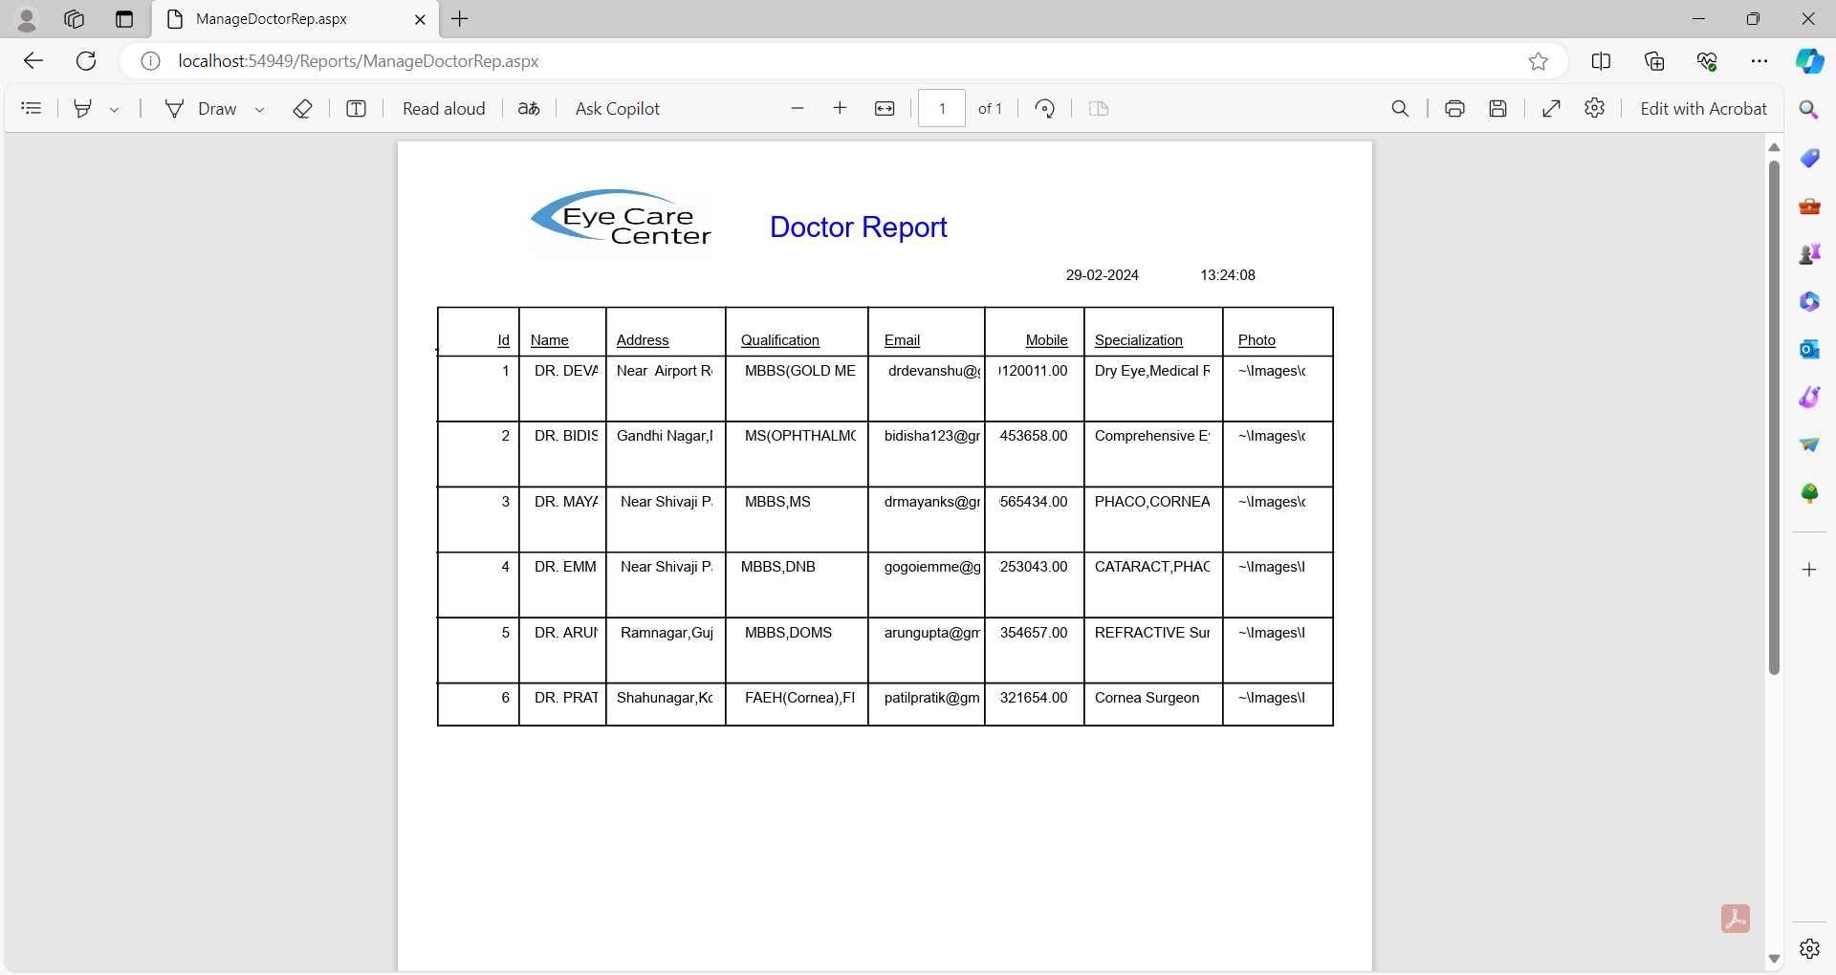

Registration Report:-

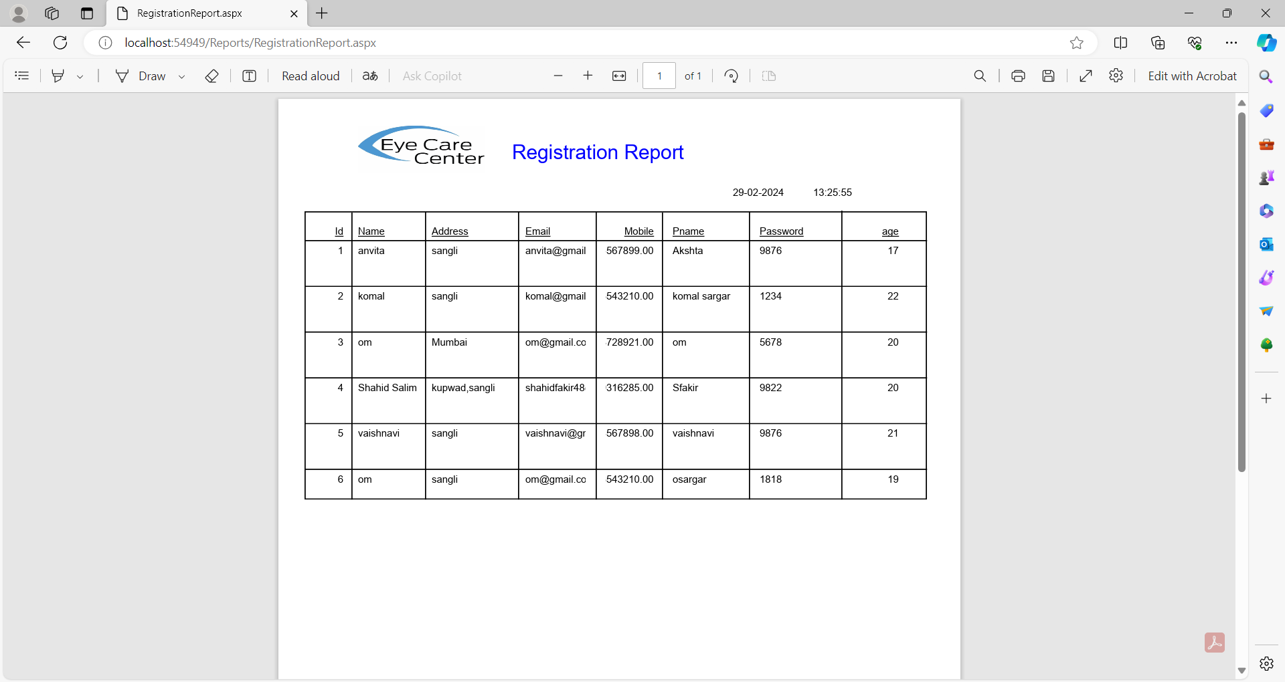

**Conclusion & Suggestion**

**Conclusion :-**

* From the “EYE CARE” system we can conclude that it is developed for the patients who can easily take an appointment at home.
* The users or patients can easily see our products and even order the glasses or lenses through this website.
* EYE CARE is the provision of appropriate , accessible and affordable care that meets patient’s eye care needs in a comprehensive and competent manner.
* EYE CARE provides the patient with the first contact for eye care as well as a lifetime of continuing care.
* The patient can easily login or registration.
* This website is user friendly and easy for any user who wants to have an access to it.

**Limitations of system:-**

There are several limitations of online Eye Care system, including:

1. Technical difficulties: Online Eye Care systems can experience technical difficulties, such as website crashes, slow loading times, and payment processing issues, which can lead to customer frustration .
2. Limited personal interaction: Unlike Eye hospitals where patients can interact with doctors, Online Eye Care system lacks the personal touch. This can lead to a less satisfying patient experience.
3. Delivery delays: Delivery times can vary greatly, especially during peak hours or busy periods, and delays can result in unhappy customers.
4. Limited eye accessory option: Some eye care system may only offer a limited accessory, which can limit the choices available to customers.
5. Bill Generate: After confirmation of order the bill of individual customer cannot get generated.
6. Reports: Less reports are generated.
7. Payment Mode: No proper payment gateway is implemented.

**Future Enhancements :-**

* We think that not a single project is ever considered as complete forever because our necessities are growing.
* As a system is flexible you can generate more report and screen as and when needed.
* The system is modified in the future as per the requirement.
* We can design the system with secure shopping using various payment gateway services.
* The patient will be even able to print their appointment details.
* More facilities will be provided in future if needed.

**Bibliography:**

**References :-**

To develop this “web application of online Eye Care” we used

ASP.NET Frontend and MySQL 2015 backend (database). We take some knowledge

Towards automation system from some books that are given below

**Books:-**

1. ASP.Net Programming - Bill Evjen, Jason Beres Bible Publication
2. ASP.NET with C#, AJAX
3. System analysis and design -Ragib Mall

**Web Sites:-**

1. www.c#corner.com
2. [www.urbanclap.com](http://www.urbanclap.com)
3. [www.google.com](http://www.google.com)